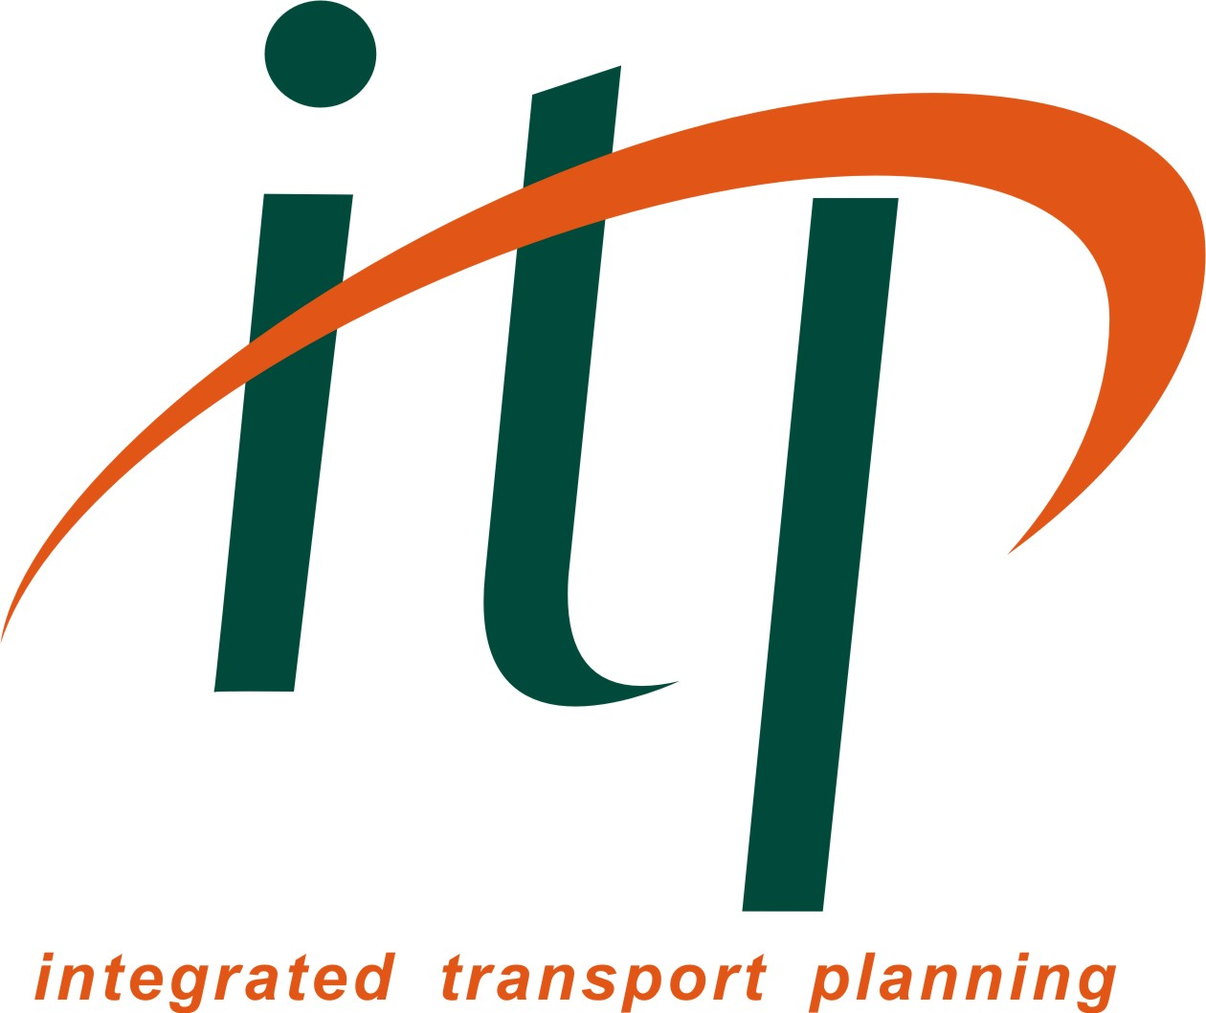
Thursday 12th March 2015
18:00 for prompt start at 18:30

2015 TPS National Pub Quiz!

To enter, team captains should provide the following information and email it to your regional TPS representative:

Team captain:
Name of TPS member:
Membership No:
Email address:
Phone no.:
Team name:
Organisation(s):
Expected number in team: | (Maximum of 5)
Region attending:

If you do not have a team and would like to be teamed up with other individuals on the night, please provide your name and contact details below:

Name:
Phone:
Email:
Region:

Our regional reps will send you more details of the food available in due course.
As usual, we will collect all entry fees (£2 for TPS members, £3 for non-members) on the evening. People will be responsible for their own food and drink bills.
PLEASE COMPLETE THIS FORM AND EMAIL TO YOUR REGIONAL REPRESENTATIVE BELOW:
London: Alina Tuerk / Sara Cole: AlinaTuerk@tfl.gov.uk / scole@peterbrett.com
West Midlands: Chris Blake Christopher.Blake@jmp.co.uk
South: James Snowdon JSNOWDON@systra.com / Dominic McGrath dominic.mcgrath@hants.gov.uk
South-west: Emma Dalton: Emma.Dalton@jacobs.com
North-west (Manchester): David Arthur david.arthur@aecom.com
Wales: Ian Southwell Ian.Southwell@vectos.co.uk
Yorkshire (Leeds): Liz Richardson Liz.Richardson@ch2m.com
North-east: Quiz details to be confirmed – contact Nicola Hill Nicola.hill@arup.com
Scotland: Stephen Canning scanning@peterbrett.com
East: Jack Eagle / Barry Wickenden / Paul McGregor Jack.Eagle@cambridgeshire.gov.uk Barry.Wickenden@aecom.com Paul.McGregor@mottmac.com

