Thursday 17th December 2009

Christmas Drinks, Transport Debate and General Meeting

Drinks 6.00pm; Meeting 6.45pm; Debate 7-8.30pm.

Smeaton Room, The Institution of Civil Engineers, 1 Great George Street, London, SW1

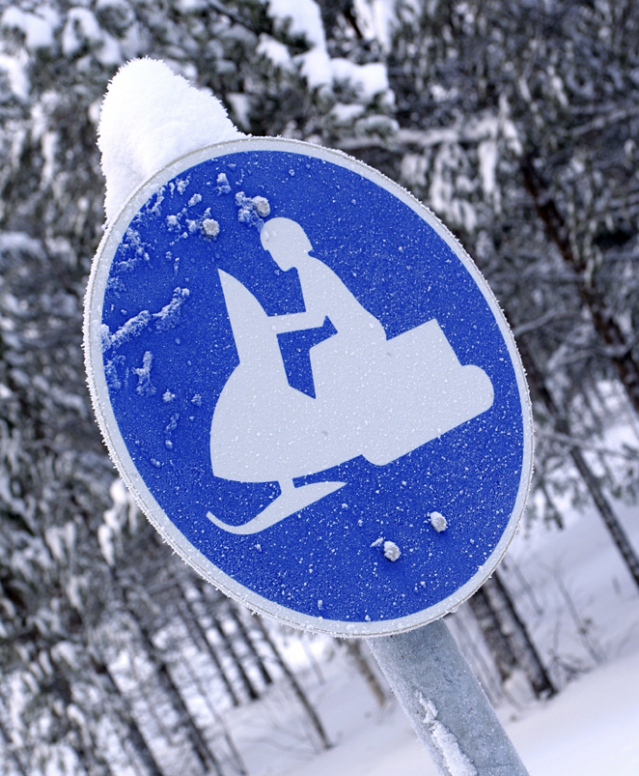
Come and join us for Christmas Drinks and what we hope will be a lively, informal debate on hot transport topics. There’ll be a small panel of current and former TPS Board members in the shape of John Dales (Urban Initiatives), Howard Potter (Transport Planning International) and Keith Mitchell (Peter Brett Associates), but we want members to set the agenda. So, when registering, please pose a question that you would like to be debated. Is HS2 the best use of £billions? Are 3 runways at Heathrow enough? Can better transport deliver both more economic growth and less carbon? What’s the difference between a street and a road? Are sleighs sustainable? Ask away, and come along to make it an evening to remember.
A short General Meeting of TPS members will precede the debate. It is necessary because the Board considers that, because of growth in membership, a change in the quorum (number of members) required for future General Meetings at which business is transacted (including the AGM) is needed to ensure that it is achievable. Details of the resolution can be found at www.tps.org.uk/main/news_general/ Members will be asked to indicate, by show of hands, whether or not they agree with the amendment.
TPS MEMBERS FREE WITH MEMBERSHIP CARD, TPN MEMBERS £5, NON-MEMBERS £10
Priority will be given to TPS members. Please register early by emailing tps@ice.org.uk with your name, organisation, telephone number and, if you are a TPS member, your TPS membership number. Alternatively, complete the form below and return it to: Transport Planning Society, 1 Great George Street, London SW1P 3AA. Or fax it to: 020 7799 1325. For booking queries, please call 020 7665 2238.

I will attend the TPS Christmas Drinks and Debate on 17th December 2009. My question for discussion at the event is:

.................................................................................................................................................................................................

Name: ………………………………………...……..…………………TPS Membership No…………….………
Organisation: .…………………………………… ………………………………
Address: …………………………………………………………………….......................................
Tel: …………………………………..............……E-mail:…….........………………………………

