Putting our best foot forward
  - Understanding the processes behind why walking infrastructure is undervalued across different countries and cultures

Introduction
Walking is, in many ways, the original transport mode. Encouraging walking has a wide range of benefits, for health, the environment, the economy and reducing pressure on other motorised modes. In London alone, the expected saving to NHS costs if every Londoner walked for 20 minutes a day is £1.6bn, along with the prevention of 1 in 6 early deaths. Walking is carbon neutral, and does not itself contribute to traffic congestion. In the UK, people walking spend 40% more in town centres over the course of a month than car drivers.
Walking infrastructure is one of the most important factors in creating an accessible transport system. The people most reliant on walking are often the most marginalised in other ways. The urban poor, women, disabled people, older people and children are all especially impacted by a lack of walking infrastructure. This is because of the ways these groups travel, their reliance on non-car modes and the importance of barrier-free environments for people with reduced mobility.
Providing footways and pedestrian crossings helps to separate pedestrians from traffic. However, walking infrastructure can also encompass a wide range of other things. Providing green routes separates pedestrians from air pollution. Implementing street lighting helps to improve perceptions of safety, particularly for female travellers. Providing dropped kerbs and tactile paving enables disabled people to travel independently. People walk in spite of a lack of walking infrastructure - walking infrastructure allows and encourages people to walk safely.
As such, pedestrian infrastructure is a vital but often undervalued element of an accessible transport system. This paper seeks to explore and summarise the reasons that contribute to walking being undervalued – not just in the UK, but across much of the globe - with a view to understanding how this might be remedied.

Methodology
Six individual interviews and one group interview were undertaken with experts from a range of relevant backgrounds, in order to understand the issues at the heart of planning infrastructure for walking. These participants are detailed in Appendix A.
These participants were approached according to the researcher’s own existing networks, but were chosen with the intention of representing a wide range of locations and types of experience. As such, each participant spoke only in reference to their personal experiences. Even so, it became quickly apparent that the issues that were raised showed consistency across different countries and angles of transport planning. This is, in many ways, the central finding of this research; that the issues facing walking appear to be recurrent in whatever context they are considered.
The semi-structured interviews followed broadly the same structure, organised around three key questions:
- In your experience, what is the attitude towards infrastructure for walking at a transport planning level?
- Why do you think that this occurs?
- What do you think would help to mitigate this issue?
Interviews were conducted using MS Teams and were recorded with permission from participants. Notes were taken during the interviews, which were then re-watched to identify key recurring themes and pull out quotes. These were recorded on post-it notes and arranged into groups/themes to enable the development of a list of consistent comments across participants. The generalisations I have made are supported by quotes where relevant.

What is the attitude?
“In theory and in policy walking is understood clearly as a mode. When it comes to design, it appears to be more or less ignored.” (John Dales)
All participants agreed that in their area of the sector, infrastructure for walking is under-appreciated, under-prioritised and under-funded. Participants highlighted that although there has been a gradual shift in thinking towards a better prioritisation of active modes and ‘vulnerable’ road users, this is incomplete.
‘What do people think about walking? I think we’ve gradually seen that sense of… yeah we’d better start thinking about people, not just trips, movement, time savings, fine, but in reality we’ve seen that shift over 20 years, that has yet to really be delivered on the ground in all but a few relatively small places.’ (Jim Walker)
In addition, there was concern that thinking on walking had been largely linked, in practice, to cycling, with the full understanding of the prioritisation of walking yet to be realised. Many respondents referred to the conflation of walking and cycling as ‘active travel’ as a result of this attitude. This has several facets. One is that planners are able to consider walking ‘covered off’ when it is included within walking and cycling plans. However, many of these plans and design guidance place greater emphasis on cycling than walking. The Government’s recent ‘Gear Change’ report is the perfect example of this – in a document that claims to present a ‘Bold vision for cycling and walking’, the word cycling is mentioned twice as many times as walking (142 vs 73). More than half (41) of the ‘walking’ mentions are part of the phrase ‘cycling and walking’. All of this is despite the fact (mentioned by several participants) that walking and cycling are actually not very compatible in terms of sharing space.
“I do think that we should de-couple walking bundled up with cycling as ‘active travel’. I think it should also have its own strategy because it’s completely different – they’re two completely different modes. Although they have the same purpose to get more people active, you can’t bundle it up together like that” (Georgia Corr)
Thinking about pedestrian infrastructure remains in the realms of marginal changes, and indeed, pedestrians are often accommodated at the margins of transport schemes. The space and capacity requirements of all other modes are considered before those of pedestrians.
“Junction capacities are based around motor vehicles – sometimes for cycling – there’s never any calibration of what it takes to get a given volume of pedestrians across safely” (John Dales)
The impact of COVID on attitudes towards walking (and transport more broadly) were also discussed.
“the last few months have given a lot more weight to the power of walking. […] the attitudes towards the infrastructure will shift towards more planning for pedestrians.’ (Georgia Corr)
“Things that may have seemed like big changes before, but people are adopting them because it is COVID times now” (Diogo Martins)

Why is this?
The core aim of this paper is to understand the reasons why walking infrastructure is under-valued. The themes which occurred consistently across all participants were easily organised into four main ‘reasons’:
- Walking isn’t a ‘real’ transport mode
- Walking isn’t very ‘sexy’
- Walking happens without planning and infrastructure
- There are other, more pressing concerns than walking
These four themes explain the lack of focus on walking infrastructure. By identifying these ‘reasons’, we can hope to identify measures to alleviate these problems. There are also interactions between the themes, which are demonstrated in the diagram, and further explained below.
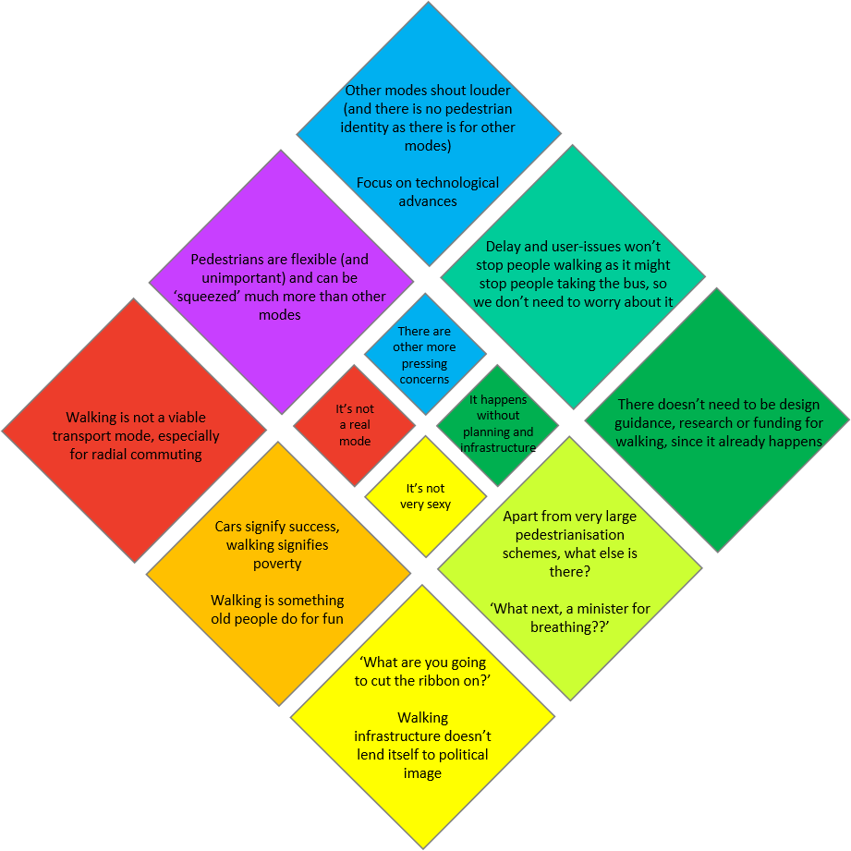

Walking isn’t a ‘real’ transport mode
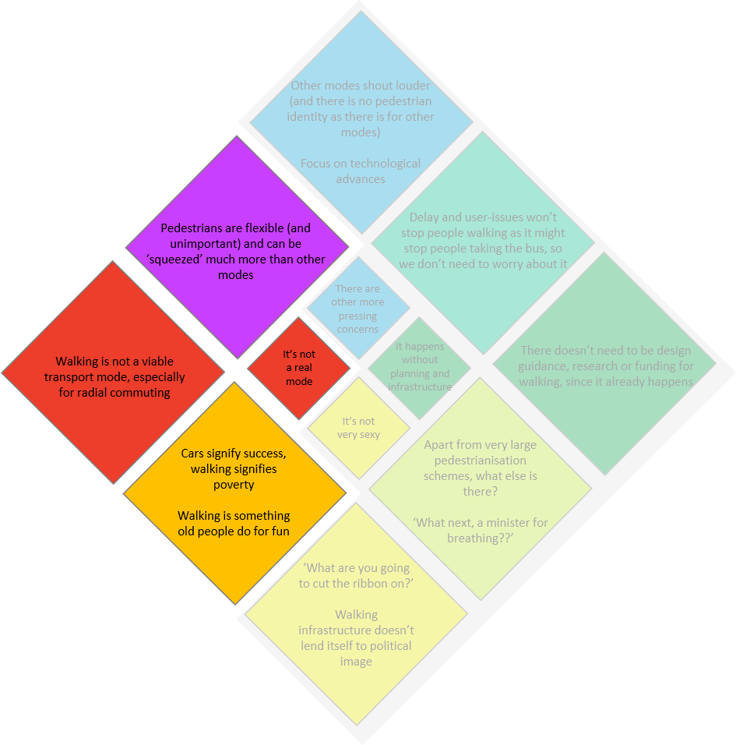
Many participants mentioned the lack of a concept of walking as a transport mode. This has various facets. Walking does not provide a viable alternative to ‘traditional’ transport modes such as radial rail or car-driver trips. This is linked to a long-standing focus of the transport industry on (typically male) journeys to work, which generally represent relatively long-range trips from residential locations (often suburbs) into employment locations (often city centres). This has resulted in the main focus of transport infrastructure upon ‘real’ (or motorised) modes which can easily tackle this length of journey, during a peak hour. In more recent years, there has been a surge in cycling for these trips, with ‘Middle-Aged Men in Lycra’ (MAMILs) using high-performance bikes to make journeys previously completed using motorised modes.
“I think a lot of focus has been on getting people cycling, […] even cycling routes, they’ve been very radial, and so I think a lot of transport planning focus has been on moving people to the city, rather than perhaps within the suburban areas. And I think COVID presents a unique opportunity here because people perhaps aren’t going into the workplace, and are spending more time locally.” (Georgia Corr)
It is well-documented that this approach ignores a huge number of more local trips made by people who are not engaged in these commuter trips – traditionally women, children, older people and disabled people. Now more than ever, with the impacts of COVID-19 dramatically reducing our reliance on the peak-hour commute, the development of infrastructure for local trips using non-motorised modes is vital. In London, over one third of all car trips are less than 2km and could be walked in up to 25 minutes. Not only could walking easily be used as the main mode for this third of all trips, but it forms a part of an even greater number of existing journeys, including all public transport journeys.
“We don’t consider ourselves to be walkers. We do walk. We all walk. But we don’t have a walking personality.” (John Dales)
“The notion of the pedestrian (or the jaywalker) only began to exist when the car started to turn up in public space.” (Cathelijne Hermans)
In addition to this, walking as a mode has very different characteristics to other, more ‘traditional’ modes. Pedestrians are inherently more flexible than vehicles (including cycles), allowing them to be ‘squeezed’ at traffic signal arrangements, and are much better able to deal with sub-standard infrastructure than other modes. For example, if a footway is too narrow for the volume of pedestrians using it, pedestrians are able to use the main carriageway for a short section in order to mitigate a ‘collision’. Pedestrians also move slowly enough that immediate diversions are possible.
“There are some key parameters for motor vehicles and cycling that break if you don’t provide them. So if the lane’s too narrow, the vehicles simply won’t get through. […] There’s this assumption that walking is the soft option – it can be pushed and squeezed.” (John Dales)
This way of thinking has particular impacts for people with mobility impairments, for whom simply stepping off of a substandard footway may not be available.
“The benefit of me [as an able-bodied man] walking one extra trip is so much smaller than a person in a wheelchair or an elderly person walking one extra trip, and those are the ones that are dependent on the higher quality infrastructure […] Putting a dropped kerb in isn’t going to double your walking trips, but if it unlocks ten trips a day for ten people who otherwise wouldn’t leave the house then the societal benefit is huge.” (Giulio Ferrini)
Finally, this narrative is also enshrined within the public psyche. Several interview participants referred to the ‘image’ of walking as a part of the reason it is not considered as a transport mode in general. Particularly in low and middle-income country (LMIC) contexts, cars signify success, while walking signifies poverty. In Europe, walking is often perceived as a leisure activity, particularly for older people. Neither of these concepts lend walking the ability to be thought of as a transport mode in the same way as other modes. Cycling has undergone a transition in some places, partly due to the rise of MAMILs, although in LMIC contexts it continues to be considered a marker of poverty.
“In Africa, if you’re walking it’s because you’re poor” (Fatima Arroyo Arroyo)
“Most of my work is primarily cycling – it’s ‘active travel’ but any of the walking work that I’m aware of has been creating maps for historic walking routes, for example, and again, that leisurely trip purpose.” (Georgia Corr)
[In the Netherlands] “Most people prefer cycling over walking. Walking is a hobby for middle-aged people.” (Cathelijne Hermans)

Walking isn’t very ‘sexy’
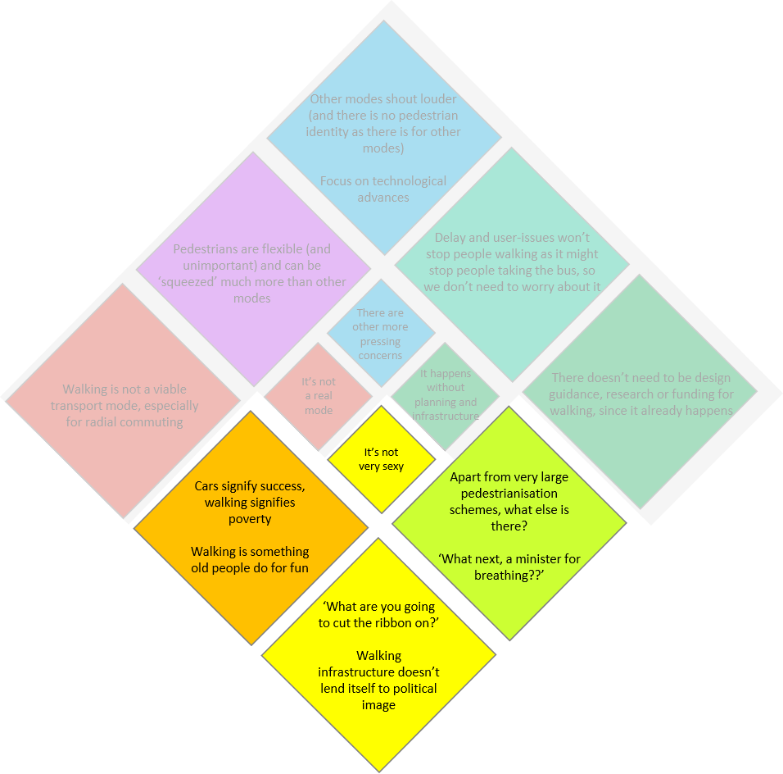
Using the Oxford Advanced Learner’s Dictionary informal definition, ‘sexy’ is taken to mean something that is ‘exciting and interesting’. In this case, few other words describe the type of appeal that transport planners and the general public alike often afford to high-speed rail or a new tram system. Even the Cycle Superhighways in London can be thought of as a transport measure with a certain amount of sexy-ness. Walking appears to lack this appeal.
This is partially due to some of the reasons mentioned in the previous section. Walking traditionally signifies poverty – an inability to afford ‘real’ transport. In Europe in particular, it is considered as a leisure activity, rather than a transport mode. In addition to this, as one interview participant stated, the very ‘everyday-ness’ of walking does not lend itself to being either exciting or interesting. As a result, there is little vocal public support for walking infrastructure, and so minimal political will to support it on any major scale.
“It’s the most hidden in plain sight mode we’ve got – everybody does it […] and I think that very everydayness of it is part of the problem.” (John Dales)
“It’s always been there – so it’s not special. […] Pedestrians have always been there – they’re so obvious that they’re overlooked.” (Cathelijne Hermans)
This lack of political will is linked to a poor understanding of what walking infrastructure might be. With the exception of large-scale pedestrianisation schemes, there is little in the way of walking infrastructure that might be ‘unveiled’ or have a political stamp put on it. In a situation where the best walking infrastructure may be (controversially) removing excess parking or traffic, there is little motivation to pursue these measures. Even large-scale pedestrianisation schemes often have a commercial drive behind them, rather than focusing on ‘walking’ per se.
“Pedestrian infrastructure is quite fundamental [in the Netherlands]. But it’s not a target group that will create voters for you.” (Frank Legters)
This misunderstanding of what walking infrastructure might be combines with the ‘everydayness’ of walking to create an almost farcical concept of planning for walking. As John Dales pointed out, the Monty Python Ministry of Silly Walks sketch demonstrates this perfectly – with the sketch portraying a department of the Civil Service dedicated only to the development of silly walks. Even in the sketch, funding for walking is short - the government, the sketch explains, is supposed to give equally to Defence, Social Security, Health, Housing, Education, and Silly Walks, but recently spent less on Silly Walks than on national defence.
“A Minister for Walking – what kind of non-job is that? What next, a Minister for Breathing?” (John Dales)

Walking happens without planning and infrastructure
Building upon this lack of understanding about what infrastructure for walking is, there seems to be a general concept that walking will occur regardless of planning or infrastructure. To an extent, this is true. People who are bound to public transport will always walk to public transport stops. In fact, most journeys include at least a short section of walking. Even people using a car to reach their destination will need to walk from their car to where they are going. Partly due to their aforementioned flexibility as ‘vehicles’, pedestrians will always be present, but they will not necessarily thrive.
“Walking is like water – it will get through somehow, it doesn’t need that much help. You can make the footway almost impossibly narrow […] they will not complain” (John Dales)
As a result of this, there is a dearth of in-depth data on walking, particularly on the under-reported short walking journeys often made by women and children, and walking as a first or last-mile mode. There are rarely data requirements or models for designing pedestrian infrastructure, and pedestrian wait-times are prioritised below vehicle capacity when programming traffic signal timings.
“It’s just something where the user experience is given little importance. There’s a recognition of ‘this is the minimum standard that we have to do’ and there’s not really an idea of what excellent looks like. There’s not an idea that through infrastructure you can shape demand, which obviously there is for all other modes of transport. But there just doesn’t seem to be this perception that it’s impossible with walking. It just seems to be this thing that’s independent of what you provide – beyond a basic provision.’ (Giulio Ferrini)
“The conversation about transport is very clear, specific and quantitative when it comes to virtually every other mode, but it’s not when it comes to walking” (John Dales)
The impacts of journey time reliability for other modes are well-documented, particularly for bus passengers. This has (rightly) resulted in a huge amount of effort and funding for bus priority measures in cities all over the world. Interview participants identified that study of these impacts did not exist for pedestrians. As discussed, pedestrians will seemingly continue to exist regardless of whether infrastructure is provided for them or not. This results in walking being pushed further and further down the priority list in relation to other transport modes.
“If you provide a high-quality bus route then people will use the bus. People don’t really know what a high-quality walking route would be.” (Giulio Ferrini)

There are other, more pressing concerns than walking
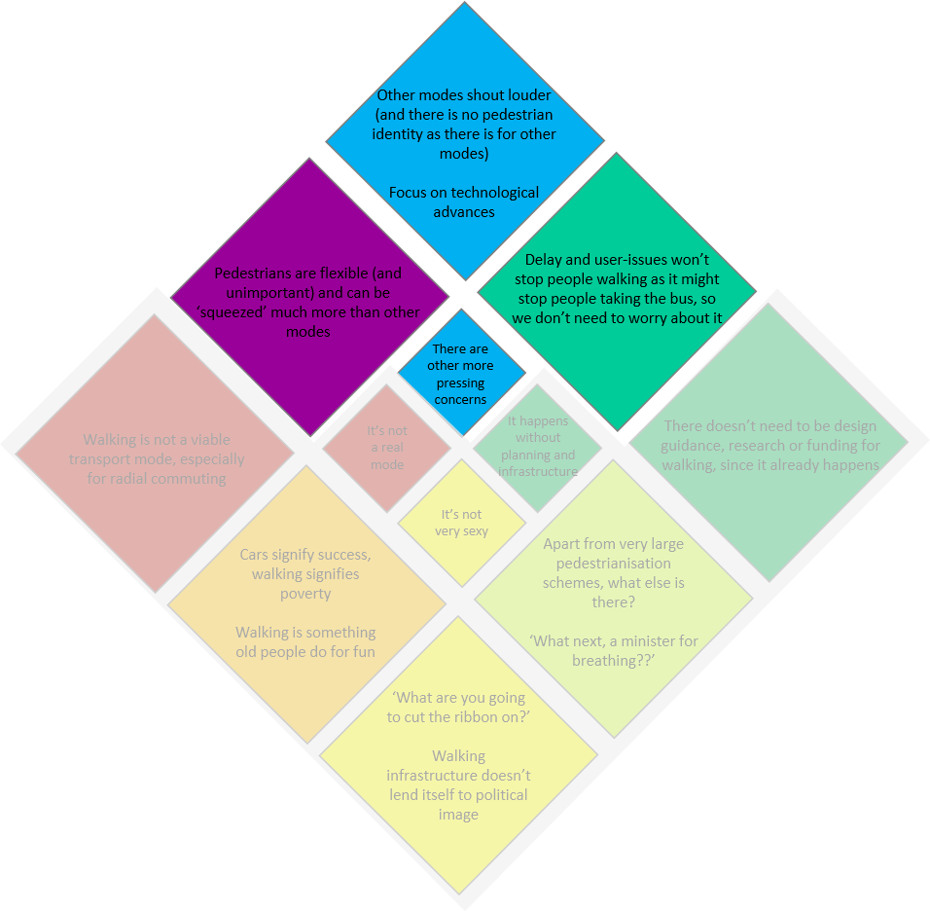
Transport professionals, governments and the general public face a wide range of challenges in relation to transport. There are pressing commitments on carbon emissions, reducing road collision mortality, alleviating capacity issues, improving economic performance, all in the face of often limited funding. There are wider issues including public health (air quality, inactivity) and pressures on housing. In the face of all these challenges, resources are not often These challenges are often approached in a techno-centric manner, with electric car subsidies and alterations to HGV designs as two key examples of this. Whilst these are important, it can lead to an ignorance of the ‘softer’ approaches which can provide some of the most cost-effective and widely beneficial changes to how people travel.
“Sometimes the best walking infrastructure is the one that simply reduces the appeal of other modes of transport” (Giulio Ferrini)
Furthermore, the way that transport is intertwined with local politics reproduces this problem. Local governments are strongly impacted by public views, often leading to a focus on modes which are represented most strongly (or vocally). Strong identities exist for car drivers and (increasingly) cyclists, providing a vocal lobby of representatives for these groups when schemes are proposed which might threaten them. For various reasons, this is much less the case for walking. The concept of walking as not a ‘real’ mode feeds in here too. Not recognising walking as a transport mode, or even an activity (when not for leisure), means that there is little concept of a ‘pedestrian identity’ among the general public to advocate for pedestrians’ rights, except in a few rare circumstances – see Oxford Pedestrians Association for an example. In the case of walking infrastructure, other modes quite literally shout louder.
“They will not complain. […] You get a lot of complaints from cyclists, there’s a lot of active advocacy for cycling. There are things you can do (or not do) for them – give them more space or build a more cycle-friendly junction.” (John Dales)
Due to the ways in which pedestrians are (seemingly) minimally impacted by poor infrastructure, particularly in comparison to other modes, there is significantly less onus on their needs being met. Pedestrians are accommodated at the margins of transport schemes, without significant consideration for their experience. A simple example of this is staggered pedestrian crossings, which provide benefits to traffic flow and capacity, but contribute to reduced pedestrian level of service, ease of use and longer wait times.
“If we have a large junction let’s say, could we reclaim that tiny bit and make the splay a bit narrower for vehicles” (Georgia Corr)
[In relation to countries outside of the Netherlands] “There is no fundamental place – we have some room left so let’s put [pedestrian infrastructure] in” (Frank Legters)

What can we do about it?
The third part of the interviews involved discussing what would improve the issues discussed here.
As is apparent from the responses to the earlier questions, there are various levels of decision-making and conceptualisation that are important to this discussion. Broadly, these are at the public perception level, the political level, and the design level. The ‘solutions’ to the problems discussed throughout this paper can be aligned to these groups. The three types of intervention are deeply interlinked.
These can generally be categorised as follows:
 | Public | Political | Design
Benefits and costs | Public awareness campaigns and behaviour change measures – create more of a pedestrian identity and ‘voice’ (required for political dedication) | Promote a cross-cutting approach – think about health, mobility and environmental quality all at once
Make it sexy | Make it ‘cool’ – how can we ‘romanticise’ walking more and make it a desirable activity? | High profile sponsorship and political leadership that commits to removing priority from motor vehicles
Make it mandatory |  | High density and mixed use development is very important for enabling walking | Enshrine pedestrians in planning law - they should be considered at all stages (as in Netherlands)

Emphasising benefits and costs
Many participants mentioned a need to better understand the costs and benefits of walking in order to drive a change in how it is considered. In general, this was not considered to be an issue for designers so much as changing ‘hearts and minds’ of both policy-makers and the general public.
“There are much more developed approaches for calculating cost-benefit ratios for public transport and highways. Calculations for walking infrastructure are very rarely done.” (Fatima Arroyo Arroyo)
At the public level, encouraging people to walk by emphasising the unique benefits of walking as a transport mode in comparison to other transport modes was raised. This includes a ‘human-level’ engagement with your environment, and also the benefits to health and inactivity (as well as the environment).
“If you want to promote walking for people, they don’t think of it as a mode – but it’s just one of the ways we can travel. We should emphasise the good things about walking to help them change their behaviour” (Ine Buuron)
“I think that you can’t emphasise the active life component enough. It also takes it away from the mobility and towards an active lifestyle and health.” (Cathelijne Hermans)
Improving public buy-in to schemes was repeatedly mentioned. This should be done through consultation and public engagement, encouraging co-design and incorporating the specific needs of users, particularly those who are often under-represented. In addition to creating environments that serve their local populations, this should also help to improve public support for schemes, as the general public are given more ‘ownership’ of the interventions. Education around the benefits and costs of different transport modes was mentioned as a vital pre-requisite to co-design approaches.
[In relation to co-design] “It’s more about making people aware […] I feel that people are not aware of how much pollution they are causing, how much space a car occupies, all of these impacts” (Diogo Martins)
There were various references to the importance of culture in these types of approaches, particularly when talking about behavioural change.
“For Dutch people, cycling is such a status symbol. Even if your bike looks crappy, that’s the best. […] But in other countries you’re a loser if you’re on a bicycle […] that’s something we don’t need to tackle here.” (Cathelijne Hermans)
Finally, making clear the costs of continuing with ‘business as usual’ is also important.
“If you want change, you need a sense of urgency […] In the culture of the Netherlands […] we are tolerant and open to change. […] And if you don’t change you will drown.” (Frank Legters)

Make it sexy
This is possibly the most nebulous of the suggested actions. There is no certain way to improve the popularity of something. Even so, many participants suggested that there were ways to place walking in the same ‘sexy’ category that cycling or trams have sometimes been able to achieve. While part of this is emphasising the benefits (and costs) as per the previous section, this is subtly different as it pertains more to the feeling of the public towards walking; what is ‘cool’. This in turn impacts on what is politically acceptable and what is prioritised at all levels.
One of the suggested ways to ‘romanticise’ walking is to emphasise the human-level engagement with the environment that walking allows.
“When I walk around the city, because you’re at such a slow pace you notice things that you don’t notice on your bike or in a car. […] We should romanticise it a little bit more.” (Cathelijne Hermans)
More than for the general public, ‘make it sexy’ refers to encouraging high-profile sponsorship and political will in relation to walking. Implicit in this is a recognition of the fact that politics is a complex and not necessarily fact-driven process. Kingdon’s concept of Policy Windows is highly relevant to this – three different streams (problem, policy and politics) must come together at once for a ‘Policy Window’ to open, allowing a topic to gain significant uptake in policy and public conciousness. The ‘fashion’ of what is politically acceptable and what is prioritised is deeply intertwined with public perceptions and global trends.
“[In the Netherlands] [c]ars are out, public transport is in (but now in a difficult position because of COVID-19), cycling has been there forever and will never go away – the next step will be focusing on the pedestrian. The Hague now has a policy of less cyclists and more pedestrians.” (Frank Legters)

Make it mandatory
There are two levels at which walking needs to be made mandatory in order for it to be properly considered within an integrated planning approach. At a planning level, high-density and mixed use development is essential
“There’s a huge interdependency with land use. Out of all the modes it’s the one that depends on that the most.[…] It tends to be more of an option for people who are living in areas with less severance, less busy roads, and those tend to be wealthier areas.” (Giulio Ferrini)
At a design level, minimum standards and an enshrinement of walking (beyond footways) at the heart of all transport and public realm schemes.
“In politics the pedestrian has not always been very high scoring in the Netherlands […] but pedestrians always have a place in infrastructure. Even in our more commercial areas there is almost always something for pedestrians.” (Frank Legters)
This must include requirements for data collection to determine demand, with the intention of assimilating how walking is conceptualised as a mode to be planned for with how other modes are approached.
“Design guidance documents where you’ve got minimum acceptable footway widths - 2.5, 2, 1.5 at a pinch - it’s utterly meaningless – what’s your demand?” John Dales
Finally, it has already been briefly discussed that often the best walking infrastructure is that which reduces the prevalence of other modes (particularly cars). This requires a political commitment to systematically reducing car use, something that is relatively rare.
“The Netherlands have been more willing than other countries to rule out cars from the city centre. In other countries it’s quite a unique position if you have no cars at all in the city centre.” (Frank Legters)

Conclusion
To conclude, there are a number of problems facing the public, politicians and transport planners in terms of effectively implementing infrastructure for walking. Across the world and across different aspects of the transport spectrum, walking is undervalued. What is most interesting about this is that the reasons for this appear to be consistent across many different countries and cultures.
These reasons are intertwined in complex ways, but can be distilled into broad categories, as discussed throughout this paper. In essence, walking has an image problem, is misunderstood as a transport mode, and is overshadowed by other concerns.
In terms of its image problem, the way people perceive walking is detrimental to how it is prioritised in practice. It is not considered to be a ‘real’ transport mode. There is little concept of a pedestrian identity as there is for other modes, resulting in a lack of drive for political focus on it. It is often associated with poverty and/or leisure, and is not considered a desirable (or ‘sexy’) activity for many people.
Furthermore, walking is misunderstood in terms of how it operates as a transport mode. It is considered to be something that occurs without planning or dedicated infrastructure, and there is a general lack of understanding about what walking infrastructure even entails.
Finally, other modes, and other priorities appear to ‘shout louder’ than walking, resulting in a consistent lack of focus on it in favour of other, more pressing concerns.
These issues were observed in the UK and elsewhere in Europe, but also in an international low-and-middle income country setting, and even in the Netherlands, generally perceived as world-leading in terms of active travel. What this shows is that walking faces the same challenges in whatever context we approach it, seemingly independent of specific country context or culture.
Fortunately, there do appear to be ways to overcome these challenges. This paper considers that identifying these challenges is the first vital step to overcoming them. The solutions need to tackle the three main target audiences, in the form of the individual (or general public), policy-makers, and transport planners and designers. They also need to respond to the identified main challenges to implementing effective walking infrastructure, and take inspiration and learning from the few places that have been more successful in developing their thinking and approach to planning for walking.

Word count: 4,943

Appendix A
Participant name | Description
Jim Walker (Walk21) | Jim founded Walk21, the international charity dedicated to ensuring the right to walk and opportunity to enjoy it is supported and encouraged for everyone across the world. Jim specialises in developing national policy and quality standards to benefit pedestrians as well as managing national campaigns and sustainable transport, active health and accessible recreation projects. His current walking project portfolio is active in 71 countries.
John Dales (Urban Movement) | John is a Founding Director of Urban Movement, a consultancy based in London providing support to councils and transport initiatives across the UK. John is a traffic engineer, transport planner and urban designer with over 30 years’ professional experience spanning strategic transport planning to concept design.
Georgia Corr (London Borough of Ealing) | Georgia is a transport planner at the London Borough of Ealing, leading on a range of behaviour change projects to encourage active travel including the West Ealing Liveable Neighbourhood and West London's first bi-borough cycling festival. Georgia was the winner of the Transport Planning Society's national bursary competition in 2019 with her paper that updated the industries knowledge of how on-demand food deliveries are made in London and why riders pick their modal choice.
Fatima Arroyo-Arroyo (World Bank) | Fatima Arroyo-Arroyo is a Senior Urban Transport Specialist in the Transport Global Practice of the World Bank, supporting the transportation agenda in Africa. Fatima is an enthusiast of integrating multidisciplinary dimensions in transport projects, such as fragility considerations, climate adaptation and technology. She leads urban transport projects with a focus in vulnerable groups, non-motorized transport, public transportation and the formalization of informal transport operators, especially in fragile environments.
Giulio Ferrini (Sustrans) | Giulio Ferrini is the Head of Built Environment at Sustrans. A chartered engineer, Giulio leads a team of designers working with local communities to create human-scale streets and places. He has undertaken award-winning independent research on active travel infrastructure and land use planning, developed the world’s first cycle swept path analysis tool and written Sustrans’ guide to low traffic neighbourhood designs.
Diogo Martins (Sustrans) | Diogo is a disabled persons rights activist, passionate about public transport, and Inclusive Design Manager at Sustrans. Much of Diogo’s previous experience is in Portugal. Diogo is particularly interested in trains, urbanism and accessibility, and has worked on a number of transportation projects including the Lisbon Pedestrian Accessibility Plan.
Ine Buuron, Cathelijne Hermans, Frank Legters (Royal HaskoningDHV) | Ine is a Behavioural Advisor at Royal HaskoningDHV. She is an experienced advisor on behavioural change in the fields of public health, road safety and sustainable mobility. Her focus is on the design and deployment of cross cutting approaches contributing to a safer and healthier living environment.  Cathelijne is Associate Director in Sustainable Mobility at Royal HaskoningDHV. She has extensive experience with strategy and policy development in a complex political-administrative context surrounding metropolitan challenges.  Frank Legters is a senior manager in Royal HaskoningDHV, responsible for Transport & Environment consultancy business for Europe. He has been a keynote speaker at the conference Walk 21 in 2019 in Rotterdam where he introduced new digital tooling (Flowtack) to improve walking experiences in inner cities. He promotes the use of real time data to support cities in managing their traffic flows and create more room for pedestrians, cyclists and public transport.

Appendix B

Acknowledgements
The structure of the paper draws inspiration from Lamb et al’s (2020) paper on ‘Discourses of Climate Delay’.
Special thanks to Tiffany Lynch and Mark Dimond for all their help in reviewing and advising on this paper, and to all of my interview participants.

TfL (2018) http://content.tfl.gov.uk/mts-walking-action-plan.pdf
https://www.justeconomics.co.uk/uploads/reports/Just-Economics-Pedestrian-Pound-Living-Streets.pdf
https://assets.publishing.service.gov.uk/government/uploads/system/uploads/attachment_data/file/904146/gear-change-a-bold-vision-for-cycling-and-walking.pdf
Peters, D., 2013. Gender and Sustainable Urban Mobility, s.l.: UNHABITAT; Uteng, T. P., 2019. State of the Knowledge Study on GENDER AND TRANSPORT in DEVELOPING ECONOMIES, s.l.: HVT.
https://www.london.gov.uk/sites/default/files/health_impact_of_cars_in_london-sept_2015_final.pdf
Kingdon, J.W. and Stano, E., 1984. Agendas, alternatives, and public policies (Vol. 45, pp. 165-169). Boston: Little, Brown.
https://www.cambridge.org/core/journals/global-sustainability/article/discourses-of-climate-delay/7B11B722E3E3454BB6212378E32985A7

