LSTF – How are Hampshire doing?
6pm, Tuesday 25th November 2014
Mitchell Room, QEII Court Podium, Winchester, SO23 8UJ
By April 2015, Hampshire will have invested approaching £25m on sustainable transport schemes and programmes through the DfT’s Local Sustainable Transport Fund, with a similar amount of match funding. This event, organised on behalf of the RTPI/TPS Transport Planning Network gives you the opportunity to learn more about the schemes being delivered, what has worked well, what have the team learnt and importantly what impact is the programme having on changing attitudes and perceptions towards sustainable transport in the County.

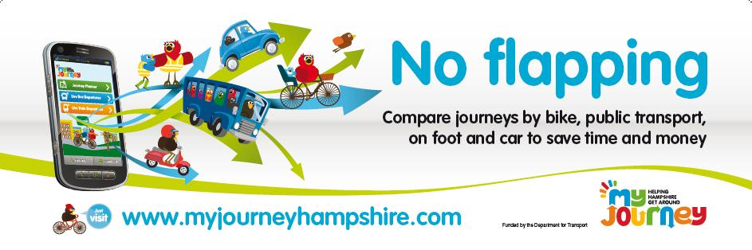

Speakers
Dominic McGrath – HCC Strategic Transport Manager + Board Director TPS
Andy Winmill – Associate Director, WSP UK
Vicky Doyle – Marketing Manager, Solent Transport
John Rider – Programme Manager Better Connected South Hampshire LSTF project

Please come along and join the discussion.

Refreshments will be available from 18:00

Booking your place - To book your place at this event please visit http://www.rtpi.org.uk/35586.aspx. If you require advice or are unable to book yourself on this event please contact Joshua Rule on 020 7929 9483

Please note that entrance to the event is free for TPS, RTPI, ICE, CIHT and CILT members with their membership card. A £5 fee applies to non-members. The fee is payable on the evening.

Certificates of attendance are available on request. Please ensure you sign the register on the night and indicate your request for a certificate and these will be issued to you electronically after the event.

