Transport Planner (Integrated Degree Apprenticeship):
Consultation for the End Point Assessment Plan
27th November 2018
Transport Planner (Integrated Degree) Apprenticeship

Standard reference number | Level of this EPA plan | Integrated
ST0698 | 6 | YES

OVERVIEW
This document sets out the proposed requirements for end-point assessment (EPA) for the Transport Planner (Integrated Degree) apprenticeship standard at level 6.
It is written for Universities in their role of end-point assessment organisations (EPAOs), who need to know how EPA for this apprenticeship must operate. It will also be of interest to Transport Planner apprentices and their employers.
This EPA has been developed in line with current Institute for Apprenticeships (IfA) requirements:
- Two forms of assessment must be utilised to assess occupational competence independently at the end of this apprenticeship, thereby assessing every Knowledge, Skill and Behaviour statement within the published Standard.
- The timing of each form of Assessment has also been phased.
- Grading criteria have also been developed for the two forms of assessment, and we propose options for the overall grading of this Apprenticeship within this document.
- Resit and retake policy has been proposed, for which we seek your feedback.
- Roles and responsibilities have also been proposed.
- Independent Assessor requirements have also been proposed, for which we seek your feedback.

ABOUT THIS APPRENTICESHIP
Delivery Model
This apprenticeship has been developed as an integrated degree apprenticeship. This is where the degree incorporates:
- on-programme academic learning,
- workplace learning and assessment, and
- independent End Point Assessment (EPA) of the Apprenticeship Standard.
Full time apprentices will typically spend 5-years working towards the apprenticeship standard, with a minimum of 20% off-the-job training, allowing for the completion of all the elements stated above.
Readiness for End Point Assessment: The Gateway
The EPA should only start once the employer is satisfied that the apprentice is consistently working at, or above, the level set out in the standard, the pre-requisite gateway requirements for EPA have been met and that they can be evidenced to an EPAO.

End Point Assessment
During the EPA apprentices must be assessed against the all knowledge, skills and behaviours (KSBs) through two forms of assessment, the outcome conferring occupational competence as a level 6 Transport Planner.
The EPA will be carried out as part of the degree programme, where the university provider will act as the independent End Point Assessment Organisation (EPAO), recruiting and training independent assessors to carry out this role.
Grading
Performance in the EPA will count towards the overall degree classification. Apprentices cannot successfully complete the degree apprenticeship without successfully passing the EPA.
Responsibilities: Awarding Universities will be responsible for the on-programme and EPA requirements. They must be on the Education & Skills Funding Agency (ESFA) Register of Apprenticeship Training Providers (RoATP). In addition, they must be approved to offer the EPA for this standard and be on the ESFA Register of End Point Assessment Organisations (RoEPAOs).
At this stage, we will seek External Quality Assurance (EQA) from the Quality Assurance Agency for Higher Education (QAA).

THIS CONSULTATION
This document sets out the proposed End Point Assessment (EPA) plan for the Transport Planner Integrated Degree Apprenticeship.
The consultation period is: Tuesday 27th November – Monday 10th December 2018.
Comments and responses are invited via email to csudworth@acenet.co.uk during this time period.

TRANSPORT PLANNING (INTEGRATED) DEGREE APPRENTICESHIP:
END POINT ASSESSMENT PLAN CONSULTATION

The following diagram sets out the proposed process and timescales for End Point Assessment for the Transport Planner (Integrated) Degree Apprenticeship:
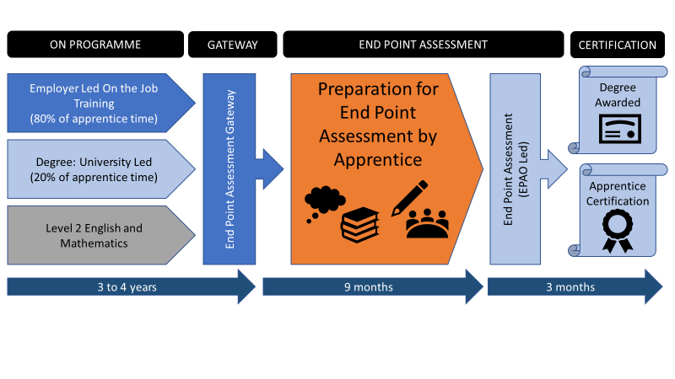
This sets out the roles that the employer (in dark blue), the apprentice (in orange) and university (in light blue) must go through in order to complete this Apprenticeship, this being:
- On programme learning and development
- Readiness check for EPA
- EPA Gateway
- EPA itself, and
- Certification.

This consultation will take each element of this diagram in turn and will ask questions to focus feedback to the Trailblazer Group prior to submission of the EPA to the Institute for Apprenticeships in early 2019.

GATEWAY

EPA Gateway is a process whereby the apprentice, the employer and the training provider (i.e. the university) all agree that the Apprentice is working at the required Standard consistently.

Every apprentice must go through this Gateway with sign off from their employer. In doing so, training providers will then apply for the remaining 20% funding to support the final costs of apprenticeship training delivery and the costs of EPA.

We now present the proposed process for EPA Gateway, complete with employer, apprentice and EPAO roles and responsibilities, and how compliance with this allows progression to EPA.
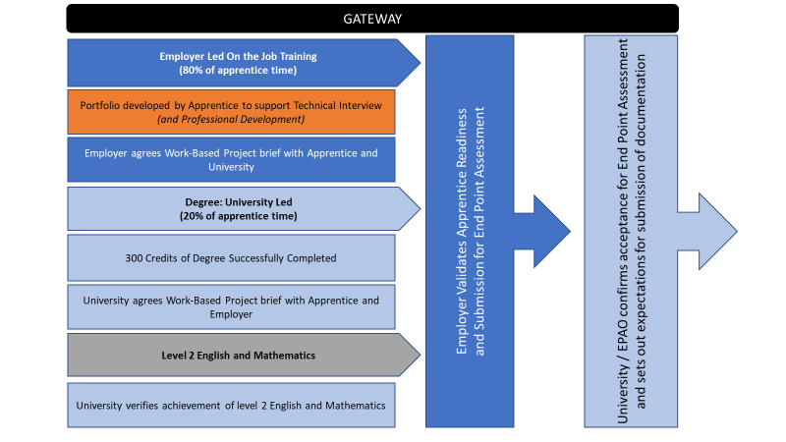

Gateway Requirements:
- An apprentice’s employer must confirm that the apprentice is working at, or above, the level set out in the standard; employers may wish to take advice from the apprentice’s University
- An apprentice must hold a portfolio to evidence demonstrating competence against the standard. The portfolio will be used to underpin the EPA technical interview. It may also be used to support the evidence requirements for professional recognition, should the apprentice wish to apply. It must therefore be presented in line with the relevant profession body’s guidance. It will typically contain performance review documentation, witness statements, training records/certificates and work products such as risk assessments, reports, meeting records, plans and costings
- An apprentice must have completed 300 on-programme credits and have passed all on-programme modules
- An apprentice without English and mathematics at level 2 on entry, must have achieved this level as a minimum
- An apprentice must have a Work-Based Project outline agreed with their employer and academic supervisor, based on their workplace need and specialism. The outline must detail the project title, scope, key activities/milestones and expected outputs/measures of success.

Q1: Do you agree with this model for EPA Gateway?
Please state acceptance, or any changes you would like to propose

In the section below, you will find the scope of the Work-Based Project to be completed by every apprentice.

Q2: Do you agree with the Gateway including an agreed Work-Based Project brief at this stage?
Please state acceptance, or any changes you would like to propose

END POINT ASSESSMENT

The trailblazer group has considered how it feels is best to assess occupational competence, with the duties and associated Knowledge, Skills and Behaviours (KSBs), being used to identify two forms of assessment that will both confirm occupational competence and be of benefit to the employer.

The two forms of assessment felt most relevant and valuable to the trailblazer group have been proposed as:
- Work-based Project: with a technical report followed by a presentation with questioning
- Technical Interview: themed interview supported by a Portfolio
These two methods will assess each duty, and their associated Knowledge, Skills and Behaviours (KSBs), at least once, with this mapping presented in Annex A.

Once the EPA Gateway is successfully achieved, the trailblazer group is proposing a total period of 12 months to fulfil both methods of EPA assessment through to certification, with the following maximum time periods of:
- 9 months for the Apprentice to carry out the work required in Phase 1 of the EPA, and
- 3 months for the Apprentice to complete Phase 2 of the EPA

During these periods, the EPAO will be required to prepare, review, and present documentation to an Independent Assessor, who will carry out the EPA and assign a Grade to the Apprenticeship.

At the same time, the University will assess the EPA documentation as part of the Degree Award to a total of 60 credits, and this will define the overall classification of the Degree itself. Apprentices cannot successfully complete the degree apprenticeship without successfully passing the EPA.

We now present the two phases of the EPA process proposed for the Apprenticeship for your consideration and feedback.

PHASE ONE: WORK BASED PROJECT AND TECHNICAL REPORT

The trailblazer group is proposing a Work-Based Project during the first phase of EPA, with this being summarised as:

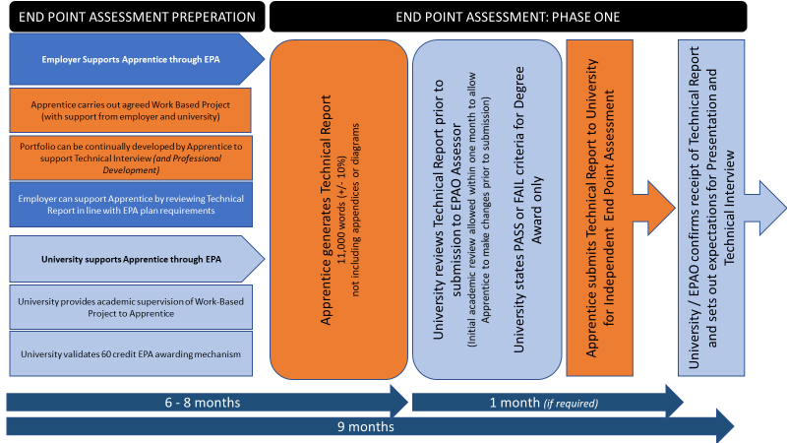

In this Phase of the EPA, the Apprentice will work to a pre-agreed Work-Based Project brief that is adaptable to the workplace setting and specialism. The Apprentice will be allowed to draw on support from their employer and academic supervisor in order to complete this Work-Based Project.

However, the Technical Report must be prepared by the Apprentice alone as this is to be an independent assessment of the Apprentices’ competence.

Details on the Work-Based Project scope and Technical Report requirements can be viewed below.

A period of six to eight months is expected for completion of the Work-Based Project and Technical Report, with a one-month period being available by the academic supervisor to review the drafted Technical Report and provide feedback to improve the Technical Report.

A maximum of nine months is provided for completion of this phase of the EPA, at which point, the Technical Report is to be submitted to the Independent Assessor for their review against the grading criteria set out in Annex B. It must be reviewed by the independent assessor before the apprentice attends the Presentation with questioning.
The University will then also review the Technical Report to support their awarding of the degree, and the classification of the degree itself.

Q3: Do you agree with the first Phase of EPA?
Please state acceptance, or any changes you would like to propose

WORK BASED PROJECT BRIEF AND TECHNICAL REPORT REQUIREMENTS

Below, we set out the proposed scope for the Work-Based Project and Technical Report and Presentation requirements.
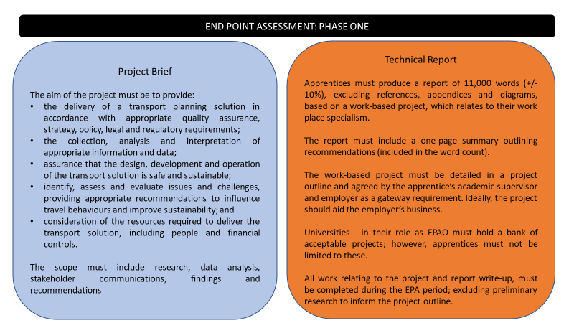

Q4: Do you agree with the scope of the Work-Based Project?
Please state acceptance, or any changes you would like to propose

Q5: Do you agree with the requirements of the Technical Report and Presentation?
Please state acceptance, or any changes you would like to propose

PHASE TWO: TECHNICAL REPORT PRESENTATION AND TECHNICAL INTERVIEW

The trailblazer group is proposing the following phase of assessment to complete the EPA process and to confer occupational competence in line with the published Standard:

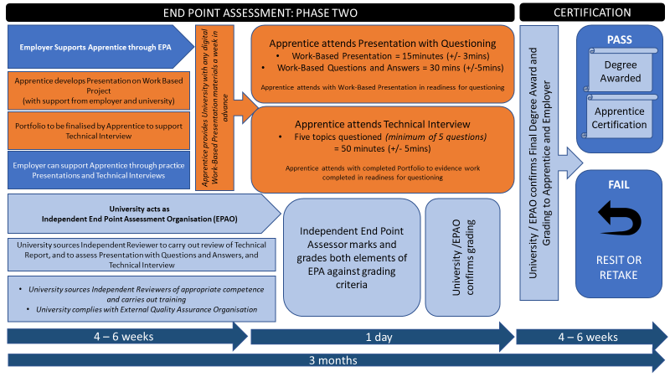

During phase two of the EPA process, the Apprentice must (in the four to six-week period post Technical Report submission) prepare the following:
- Work Based Project Presentation
- Portfolio to support the Technical Interview

The EPAO / University will agree and set a date with the Independent Assessor, the Apprentice and their Employer during this period.

The Independent Assessor will also utilise this time period to review the Technical Report against the grading criteria set out in Annex B before the apprentice attends the presentation with questioning.

On the date set, the Apprentice will attend both the Presentation with questioning, and the Technical Interview.
The Presentation component and Technical Interview must take place in a controlled environment; a room free from distractions and influence, with sufficient space for all present. It is anticipated a room will be sourced at a University’s or employer’s premises to minimise cost.
Q6: Do you agree with the second Phase of EPA?
Please state acceptance, or any changes you would like to propose

The details of the Presentation and Technical Interview are presented below.
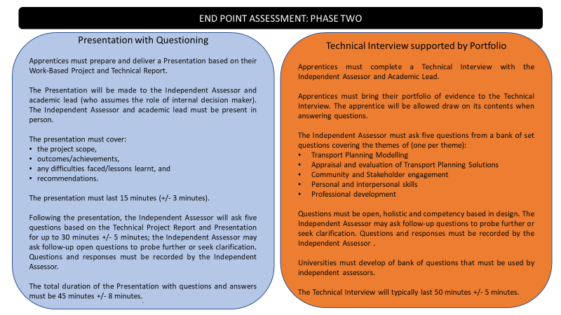

Presentation: There are no restrictions on how apprentices deliver the presentation or support resources/materials used. However, any equipment requirements for example, Powerpoint, whiteboard, flip chart facilities must be agreed with the University - in their role of EPAO, at least one week in advance of the date of the presentation.

Universities - in their role as EPAO, must develop of bank of sample questions, although independent assessors will need to tailor the questions according to the evidence presented via the report and presentation.

Q7: Do you agree with the requirements of the Presentation with Questioning?
Please state acceptance, or any changes you would like to propose

Q8: Do you agree with the requirements of the Technical Interview?
Please state acceptance, or any changes you would like to propose

GRADING

Performance in the EPA will count towards the overall degree classification. Apprentices cannot successfully complete the degree apprenticeship without successfully passing the EPA.
Performance in the EPA will be graded and determine the apprenticeship grade of pass, merit, distinction or fail.
Apprentices must pass both assessment methods to gain an EPA/apprenticeship pass, merit or distinction.
A pass will demonstrate that the apprentice has met all the requirements of the standard. Apprentices achieving a merit or distinction will be demonstrating performance above the minimum requirements of the standard.
Grading is based on the following principles:
Assessment Method | Pass Statements | Distinction Statements
Work-Based Project | 18 | 18
Technical Interview | 13 | 13
Total | 31 | 31
OVERALL GRADING CRITERIA
FAIL | DID NOT MEET PASS CRITERIA IN ALL 31 STATEMENTS
PASS | ACHIEVED ALL 31 PASS STATEMENTS AND ABOVE
MERIT | ACHIEVED A MINIMUM OF ALL 31 PASS STATEMENTS PLUS 14 DISTINCTION STATEMENTS (45% DISTINCTION)
DISTINCTION | ACHIEVED A MINIMUM OF ALL 31 PASS STATEMENTS PLUS 20 DISTINCTION STATEMENTS (65% DISTINCTION)

Q9: Do you agree with the grading criteria presented above?
Please state acceptance, or any changes you would like to propose

Independent assessors will be responsible for grading each assessment method, in accordance with the grading criteria for each EPA method detailed in Annex B.
Independent assessor decisions must be subject to moderation (External Examiner review). Grades must not be confirmed until after moderation.
Q10: Do you agree with the pass and distinction criteria presented in Annex B?
Please state acceptance, or any changes you would like to propose

RESIT AND RETAKE POLICY

Apprentices will be offered the opportunity to take a re-sit/re-take in line with a University’s academic regulations.
A re-sit does not require the apprentice to undertake any additional training/learning, whereas a re-take does.
The apprentice and their employer must agree that a re-sit/re-take is an appropriate course of action; they may wish to take advice from the apprentice’s University.
Both assessment methods must be passed in the same 12-month period, otherwise the EPA must be re-sat/retaken in full.
Re-sits/re-takes will not be offered to apprentices wishing to move from pass to distinction.
Apprentices who re-sit/re-take will only be able to achieve a pass for that assessment method, unless the University confirms that there were exceptional circumstances beyond the control of the apprentice that resulted in the fail.
The University – in its role as EPAO must ensure that a different work-based project and technical interview are used in the case of a re-sit/re-take.
Q11: Do you agree with the resit and retake policy criteria presented above?
Please state acceptance, or any changes you would like to propose

END POINT ASSESSMENT INDEPENDENT ASSESSOR(S)
Universities, in their role of EPAO, must appoint:
- Independent assessors to mark an apprentice’s work-based project, technical report, presentation and technical interview
- An Academic Lead to advise independent assessors
Independent assessors must meet the following requirements:
- Be independent of the on-programme delivery, the apprentice and their employer i.e. there must be no conflict of interest
- Hold a relevant degree and have significant experience in the transport planning field or operated as a transport planner at or above the level of the standard
- Be an active member of a relevant transport planning professional body
- Have completed an induction covering the requirements of the standard and assessment practice and attend at least one standardisation meeting per year
It is anticipated that the same independent assessor will mark an apprentice’s work-based project report, presentation and technical interview to aide efficiency, however this is not a requirement and Universities may schedule independent assessors to ensure cost effective allocation of resources.
Independent assessors should be sourced from another University, industry or a professional body; or if none of the above options are available the independent assessor can be from the same University but must be independent of the apprentice’s on-programme learning and assessment.
Independent assessors will solely determine the grade for the apprenticeship based on the grading criteria presented in Annex B.
The independent assessor and academic lead will collectively provide an audience for the presentation and technical interview, which is reflective of conditions a transport planner would face when presenting a project in the workplace.
Independent assessors will be advised by an Academic Lead, who will be present during the work-based project presentation and technical interview, with their role being to provide specialist technical advice on the apprentice’s project. However, they must not have any role in the decision-making process. They must not provide information on behalf of the apprentice or influence in the apprentice in any way. Their role is purely is provide information to the independent assessor on request.
The University academics are expected to provide their services free of charge/within the cost of the degree.
Any payment for independent assessors to assess the apprentice lies with the University.
Q12: Do you agree with the requirements for Independent Assessors presented above?
Please state acceptance, or any changes you would like to propose

Roles and Responsibilities

Role | Responsibility
Apprentice | - complete the on-programme element of the apprenticeship  - prepare for and complete the EPA
Employer | - identify when the apprentice is ready to pass the gateway and undertake their EPA  - engage with the Training Provider throughout the duration of the Apprenticeship  - engage with the Training Provider to agree a suitable work-based project  - ensure IA has access to relevant company systems / processes / documents to support the end point assessment
Independent Assessor (IA) | - be independent of the apprentice, their employer and training provider(s) i.e. there must be no conflict of interest  - maintain current occupational competency.  - hold a relevant degree and significant experience in the field as a Transport Planner  - be an active member of a relevant transport planning professional body  - have had training from their EPAO in terms of good assessment practice, operating the assessment tools and grading  - have the capability to assess the apprentice at this level  - attend the required number of EPAOs standardisation and training events per year (as defined in the IQA section)
EPAO / University | - appoint administrators/invigilators and markers to administer/invigilate and mark the EPA  - provide training to the independent assessors they employ to undertake the EPA  - have no direct connection with the apprentice, their employer or training provider i.e. there must be no conflict of interest  - have processes in place to conduct internal quality assurance and do this on a regular basis  - organise standardisation events and activities in accordance with this plan’s IQA section  - organise and conduct moderation of independent assessors’ marking in accordance with this plan  - have, and operate, an appeals process

Q13: Do you agree with the roles and responsibilities for each individual in the EPA?
Please state acceptance, or any changes you would like to propose

UNIVERSITY / EPAO INTERNAL QUALITY ASSURANCE
Internal quality assurance refers to the requirements that a University in their role as EPAO must have in place to ensure consistent, reliable, accurate and valid assessment decisions.
EPAOs for this standard must undertake the following:
- Appoint independent assessors and panel members that meet the requirements as detailed in this plan – see above
- Produce assessment tools and supporting materials for the EPA that follow best assessment practice, including a sample bank of projects, sample presentation question bank, technical interview question bank and assessment outcome recording documentation.
- Universities must develop of project and question banks of sufficient size to mitigate predictability and review them regularly to ensure they are fit for purpose. It is recommended that representative employers contribute to the development of project/question banks; where they do this they must put measures in place to ensure question security.
- Provide induction training for independent assessors in terms of good assessment practice, operating the assessment tools and grading
- Operate regular standardisation events that enable assessors to attend a minimum of one event per year
- Operate moderation (external examiner review) of assessment activity and decisions, through examination of documentation and/or observation of activity, with a minimum of 10% percent of each independent assessors’ assessments moderated

EXTERNAL QUALITY ASSURANCE
The Institute for Apprenticeships is exploring whether QAA can undertake external quality assurance for this standard, arrangements will be confirmed by the Institute for Apprenticeships prior to publication.

Professional Body Recognition
Completion of the apprenticeship is designed to be recognised by the relevant professional institutions as contributing towards the appropriate level of professional registration (Transport Planning Professional).
However, it is recognised that additional learning, managerial skills and experiential evidence will be required.

Implementation
Affordability: It is anticipated that the EPA will represent approximately 15% of the funding band for this apprenticeship, based on the proportion of the degree that constitutes EPA and quotes provided.
Volumes: It is anticipated that there will be 50 starts per year on this apprenticeship. Universities will need to develop integrated degree programmes that meet the requirements of this plan, including EPA tools, processes and procedures.
ANNEX A:
ASSESSMENT MODES FOR KNOWLEDGE, SKILLS AND BEHAVIOURS
KEY: | WORK BASED PROJECT | WP | TECHNICAL INTERVIEW | TI

Knowledge  A Transport Planner will know and understand the: |  | WP | TI
K1 | K1: principles and processes of transport policy and planning practice for various modes of transport. This includes the key components and stages that should be followed in the development, approval and implementation of transport plans and the procedures for gaining approval for development schemes through the statutory consultation processes involving the public. | X
K2 | K2: formal planning and design requirements for transport systems, which can include highways and traffic, buses, intermediate modes, rail, light rail, freight, airports or ports. | X
K3 | K3: national, regional and local policies relating to transport planning governance and the key factors that affect them. | X
K4 | K4: key principles and techniques of project initiation, management and evaluation, including risk, resource, health and safety, change control, and financial management. | X
K5 | K5: regulations related to transport, health and safety, environmental impact, legal, development and planning and equality and diversity requirements. | X
K6 | K6: principal sources and key characteristics of transport statistics, data, and their assessment techniques. This includes their relative strengths and weaknesses, any regulatory, formal and advisory requirements relating to their use, and best practice relating to the analysis and storage of, and access to data, and the potential use of new technologies such as Big Data, qualitative and quantitative behavioural research, GIS, and accessibility that may be used in transport planning. | X
K7 | K7: main methods of data collection and assessment techniques and validity checks used in the planning, assessment, monitoring and evaluation of transport solutions for a range of transport modes. This must include the evaluation of the quality, quantity and relevance of the data available. | X
K8 | K8: principles of traffic and travel generation, as well as the key factors that affect the demand for a range of transport modes, locally, regionally, and nationally. |  | X
K9 | K9: principles of transport modelling and forecasting, design, application and interpretation (applying widely used specialist modelling software packages and related tools). This must include the evaluation of the quality, quantity and relevance and possible impacts in the model output. |  | X
K10 | K10: principles and key characteristics of the standard assessment techniques widely used in the evaluation of transport solutions, including economic analyses and other assessment types, such as environmental, accessibility, safety, security, or land use. |  | X
K11 | K11: principles and techniques used for monitoring and evaluation of the performance and impact of transport solutions. |  | X
K12 | K12: inter-relationship between transport and economic activity, land use, climate change and the local environment as well as how transport systems and services can be integrated with other elements of development plans. | X
K13 | K13: principles and key characteristics of the operation of a transport system or service, including their key features, design, and performance. | X
K14 | K14: principles underlying bidding for or procuring contracts or projects, and their subsequent financing. | X
K15 | K15: principles of travel planning, including those of behavioural change, the socio-economic, health and environmental consequences of travel by different modes. | X
K16 | K16: principles underlying community involvement, stakeholder engagement, and public consultation in transport planning, including the main approaches used, and the assessment of the findings to identify transport needs and develop solutions. |  | X
K17 | K17: preparation, production, review and presentation of high quality accurate information in well-structured technical and non-technical documentation for different interested parties including public and stakeholders, and clear recommendations in accordance with relevant strategy, policy, legal requirements, codes of practice and funding requirements. | x | X
K18 | K18: importance of professional and ethical conduct relating to their role including the values and standards by which they maintain up to date technical knowledge and skills through CPD and knowledge of all relevant laws and guidance so as not to discriminate or breach the requirements of your organisation. |  | X
K19 | K19: ways in which they can identify and access support and specialist expertise when required, both internal and external to your organisation and build networks to contribute to the broader profession. |  | X
K20 | K20: key principles of how to manage and appraise their own personal and professional development, and how to guide and encourage colleagues in their professional development, by providing fair, regular and useful feedback and appropriate support when needed. |  | X

Skills  A Transport Planner will be able to: |  | WP | TI
S1 | S1: apply and comply with transport policy and planning practice for various modes of transport within relevant national, strategic and local policy contexts, and assess and evaluate the principal impacts of such policies on particular projects. | X
S2 | S2: determine and apply appropriate methods to design transport schemes, providing for integration between different transport modes and systems, with the intention of providing efficient and secure transport services. | X
S3 | S3: apply and comply with policies and regulations, including those relating to transport, health and safety, environmental, legal, planning and equality and diversity, and with their organisation’s formal procedures and practices. | X
S4 | S4: effectively manage tasks and projects, to agreed time and resource budgets, through the application of appropriate project management tools and techniques. | X
S5 | S5: apply, analyse and evaluate a broad range of appropriate transport statistics and data, utilising appropriate software and digital solutions, to inform and enable decision making within the development of transport solutions. This includes liaising with relevant organisations, such as the police, highway authorities and transport operators, to access a range of data sources and surveys for different modes or travel contexts as well as assessing data suitability, validity, quality, and accuracy relative to its intended application. | X
S6 | S6: determine the method, manage the collection, analysis, evaluation, and monitoring of data used in the development or delivery of transport solutions. This includes assessing data suitability, validity, quality, and accuracy relative to its intended application. | X
S7 | S7: use advanced techniques for the analysis of traffic and travel generation and demand, to enable the evaluation and monitoring of transport solutions, taking account of economic (cost-benefit) analyses. |  | X
S8 | S8: select, specify, and use a range of transport models and forecasting techniques to support the interpretation of proposed transport solutions. This will include the evaluation of models for local and strategic transport and different modes of transport, using appropriate software packages. |  | X
S9 | S9: specify the data requirements and targets against which the effectiveness and impacts of a transport policy, plan or scheme can be measured. This includes designing, managing, and monitoring programmes to assess performance over time including the effects on the economy, and other factors such as environmental, accessibility, safety, security, or land use. |  | X
S10 | S10: determine the needs of stakeholders in developing transport solutions. |  | x
S11 | S11: plan various stages of a commercial or operational management scheme in transport, such as initial project development, feasibility study, detailed design, procurement, funding, implementation or assessing effectiveness. | X
S12 | S12: identify and recommend appropriate types of finance, or funding, for a transport scheme, and contribute to the bidding or procurement of transport planning contracts or projects. This can include establishing and agreeing specifications, budgets, timescales, identifying and assessing possible risks, and preparing or evaluating technical briefs. | X
S13 | S13: design, promote, implement and evaluate travel planning programmes to increase travel awareness and achieve changes in travel behaviour. This includes setting, monitoring and evaluating targets, identifying and assessing likely benefits, and communicating and liaising informatively and effectively with stakeholders. | X
S14 | S14: plan, refine and analyse programmes of community involvement, stakeholder engagement or public consultations, to identify transport needs and to develop transport solutions. |  | X
S15 | S15: communicate effectively orally and in writing in both formal and informal contexts. Prepare written reports and make presentations, participate and manage meetings, contribute to discussions, and listen actively to ensure the views of others are taken into account appropriately. Seek feedback on your own performance so you can look for ways to improve it. |  | X
S16 | S16: apply appropriate transport, environmental impact and development planning laws, regulations and procedures, taking into account the evaluation of public testing and best practice, in gaining formal consent for transport solutions. | X
S17 | S17: manage the delivery of high quality accurate, well-structured and organisationally compliant documents and recommendations for the work for which they are responsible and to a level appropriate for whom they are intended. This may include written reports, oral presentations, designs, models, calculations, reports and drawings, surveys designs, and calculations. | X
S18 | S18: manage their own work independently within the limits of their authority and responsibility, making use of support and specialist expertise when appropriate. Develop and maintain productive working relationships with stakeholders and colleagues and support, guide, and motivate team members to enable them to achieve the team’s objectives as well as their own. Actively seek and provide feedback, support decision making processes, and manage any conflicts of interest that may arise in their work with integrity, fairness and consistency in decision making. |  | X
S19 | S19: develop their own professional competence reflecting on their CPD records and develop an extended network to support the relevant professional organisations and maintain the required standard of, ethical behaviours and codes of conduct, associated with transport planning. |  | X

Behaviour  A Transport Planner will: |  | WP | TI
B1 | B1: demonstrate a commitment to improving the efficiency and effectiveness of transport systems through innovative solutions that support economic growth and a more sustainable society. | X | X
B2 | B2: demonstrate self-awareness of knowledge and skills, and only undertake work which they are competent to do. |  | X
B3 | B3: demonstrate a strong personal commitment to health, safety, and welfare, equality and diversity, organisational, professional and ethical standards (including data protection, client confidentiality, anti-bribery and corruption) recognising obligations to society and the profession. |  | X
B4 | B4: work effectively and independently, including time-management, prioritisation, organisation, and delegation whilst being aware of the needs of others. | X | X
B5 | B5: have an open-minded and critical approach to work and achieving outcomes. | x | X
B6 | B6: have an active and positive attitude to collaborative working, respecting the benefit that diversity can bring. Demonstrating confidence and flexibility in dealing with new and changing situations. |  | X
B7 | B7: demonstrate personal effectiveness by taking responsibility for personal and professional development, for example, by demonstrating a lifelong commitment to learning and development, identifying appropriate continuing and professional development necessary to maintain and enhance knowledge and competence as a transport planner. |  | X

ANNEX B: GRADING CRITERIA
The table below details the grading criteria for both assessment methods.
It is based on the following principles:
- pass criteria show the apprentice is demonstrating competence against all 31 pass criteria; merit and/or distinction criteria build on the pass criteria
- to achieve a pass for an individual assessment method – pass or distinction criteria must be demonstrated against all pass statements
- to receive a distinction - 65% or more of the 31 statements must be demonstrated at distinction, with all other KSBs demonstrated at pass
- to receive a merit- 45% or more of the 31 statements must be demonstrated at distinction, with all other KSBs demonstrated at pass
Work-Based Project: Technical Report, Presentation and Questioning Grading Criteria
Topic | DUTY | KSB Statements | FAIL | PASS | DISTINCTION
Creation through to delivery of transport plans | create, plan, coordinate and deliver transport planning projects, processes or policies/solutions. Transport Planners provide and review highly complex technical input, provide advice and guidance, identify challenges, adapt and refine their approach to solving transport challenges. | K1: principles and processes of transport policy and planning practice for various modes of transport. This includes the key components and stages that should be followed in the development, approval and implementation of transport plans and the procedures for gaining approval for development schemes through the statutory consultation processes involving the public. | Did not meet pass criteria | Displays evidence in the written report of having understood transport planning practices and regulatory requirements in their work-based project and is able to cite the main concepts and processes needed to understand this. | Displays a deep and broad understanding of relevant transport planning theory, practices, policies and regulatory requirements for their work-based project in both the written report and presentation.  Demonstrates an ability to draw on theory from different branches of transport planning and transport modes.  In the presentation, demonstrates how their work-based project could be put forward for approval for development.
 |  | S1: apply and comply with transport policy and planning practice for various modes of transport within relevant national, strategic and local policy contexts, and assess and evaluate the principal impacts of such policies on particular projects. |  | Demonstrates an ability to apply relevant transport planning practice and policies and consider the key factors that affect the solution presented in the written report. | Demonstrates an ability to identify the main theoretical issues, policies and planning practices, explain them and consider how changes to these might impact on transport solutions.
 |  | K3: national, regional and local policies relating to transport planning governance and the key factors that affect them.
Providing information in line with requirements | prepare, produce, review and present documents and recommendations to support the delivery of transport solutions. They seek and provide information, carry out problem solving and support decision-making processes, in accordance with relevant strategy, policy, legal, regulatory and funding requirements, and codes of practice. | K5: regulations related to transport, health and safety, environmental impact, legal, development and planning and equality and diversity requirements. | Did not meet pass criteria |  | Demonstrates project management techniques, theory and practice utilised throughout the project to deliver the transport planning solution on time, with consideration and evaluation of resource needed to deliver the transport solution.
 |  | S3: apply and comply with policies and regulations, including those relating to transport, health and safety, environmental, legal, planning and equality and diversity, and with their organisation’s formal procedures and practices. |  | Uses project management tools, techniques or practices to deliver transport planning solutions on time.
 |  | S4: effectively manage tasks and projects, to agreed time and resource budgets, through the application of appropriate project management tools and techniques.
 |  | S17: manage the delivery of high quality accurate, well-structured and organisationally compliant documents and recommendations for the work for which they are responsible and to a level appropriate for whom they are intended. This may include written reports, oral presentations, designs, models, calculations, reports and drawings, surveys designs, and calculations. |  | Summarises the key evidence in the work-based project through appropriate use of diagrams, designs, and data, complete with recommendations to implement the transport solution. | Demonstrates an ability to assess the validity of different methods or data used in the various transport solutions considered, and to comment on the appropriateness of the solutions presented.  Able to confidently and convincingly explain any differences in results from their work when compared to published transport solutions / similar projects in the presentation.

Quality Assurance of Project Outputs | deliver timely quality assured project outputs, provide progress reporting of tasks and projects, and manage resources including people, apply financial controls and budgets. | K4: key principles and techniques of project initiation, management and evaluation, including risk, resource, health and safety, change control, and financial management. | Did not meet pass criteria | Demonstrate consideration of project management principles through clear and well-structured report and presentation. | Demonstrate evidence of applying quality assurance checks to ensure robustness of their proposed solution.  Can explain what these checks mean and why they matter, and any remaining uncertainties for which they have not been able to account for.
 |  | K17: preparation, production, review and presentation of high-quality accurate information in well-structured technical and non-technical documentation for different interested parties including public and stakeholders, and clear recommendations in accordance with relevant strategy, policy, legal requirements, codes of practice and funding requirements. |  | Writing and communication is clear and well structured.  Charts, diagrams, designs are used to aid understanding.  Word count is adhered to. | Displays and ability to use language (written and oral) which is clear, formal, structured, succinct and addresses the relevant issues.  Demonstrates an ability to convey complicated transport concepts very simply and directly.  Presentation is delivers confidently and clearly, with evidence of having sued effective approaches (e.g. tables, charts, designs, diagrams) to aid understanding.
 |  | S11: plan various stages of a commercial or operational management scheme in transport, such as initial project development, feasibility study, detailed design, procurement, funding, implementation or assessing effectiveness. |  | Demonstrate clear planning of the different stages of a transport planning project. | Demonstrate how changes in project scope affects the different stages of a project plan.
 |  | B4: work effectively and independently, including time-management, prioritisation, organisation, and delegation whilst being aware of the needs of others. |  | In the presentation and discussion, can demonstrate how they planned their work effectively managing time and resources efficiently. | In their presentation and discussion, demonstrate an ability to adapt to change to successfully achieve the project outcome.
 |  | B5: have an open-minded and critical approach to work and achieving outcomes.

Managing Data | lead the collection, analysis and interpretation of complex transport planning information and data to support the development of transport solutions. | K6: principal sources and key characteristics of transport statistics, data, and their assessment techniques. This includes their relative strengths and weaknesses, any regulatory, formal and advisory requirements relating to their use, and best practice relating to the analysis and storage of, and access to data, and the potential use of new technologies such as Big Data, qualitative and quantitative behavioural research, GIS, and accessibility that may be used in transport planning. | Did not meet pass criteria | Displays evidence in the written report of having constructed a data set and used statistical assessment techniques (or software) to carry out appropriate data analysis.  Displays knowledge of the correct data to use and the outcomes of their analysis is interpreted correctly. | Displays evidence of understanding a range of statistical techniques and can explain how they chose the appropriate method of their analysis in the presentation.  Displays evidence of having considered how the data has been collected and compiled and the impact this might have on the analysis and conclusions drawn.  Application of a range of data checks on the statistical software.
 |  | K7: main methods of data collection and assessment techniques and validity checks used in the planning, assessment, monitoring and evaluation of transport solutions for a range of transport modes. This must include the evaluation of the quality, quantity and relevance of the data available. |  | Displays a working knowledge of the different methods of data collection and the checks used in the assessment of the validity of the data.  Displays an understanding of the strengths and weaknesses of the data used. | Demonstrates an ability to consider the validity of data, such as whether it is based on a small sample size, and to adapt that analysis accordingly.  Demonstrates an ability to use data to draw clear and correct conclusions that consider external factors that might affect the results.
 |  | S5: apply, analyse and evaluate a broad range of appropriate transport statistics and data, utilising appropriate software and digital solutions, to inform and enable decision making within the development of transport solutions.  This includes liaising with relevant organisations, such as the police, highway authorities and transport operators, to access a range of data sources and surveys for different modes or travel contexts as well as assessing data suitability, validity, quality, and accuracy relative to its intended application. |  | Displays an ability to choose and appropriate analytical approach by drawing on past research and theory. | Demonstrates a deep judgement when deciding on the overall approach, considering data availability, time pressures, and is able to judge between methods to choose one which will have the best chance of providing robust findings.  This ability should be evident in both the written report and presentation.  Shows a clear consideration of the uncertainty and validity of data and statistical results, and the limits of their analysis.
 |  | S6: determine the method, manage the collection, analysis, evaluation, and monitoring of data used in the development or delivery of transport solutions. This includes assessing data suitability, validity, quality, and accuracy relative to its intended application.
Designing Transport Solutions | contribute to the preliminary and detailed design, development, and operational appraisal of safe and sustainable transport solutions. | K13: principles and key characteristics of the operation of a transport system or service, including their key features, design, and performance. | Did not meet pass criteria | Is able to demonstrate a capability to apply design skills. | Is able to demonstrate a knowledge of the operation of a transport system through an assessment its key features and performance.
 |  | K2: formal planning and design requirements for transport systems, which can include highways and traffic, buses, intermediate modes, rail, light rail, freight, airports or ports. |  | Displays evidence in the written report of having understood the planning and design requirements in their work-based project and is able to cite the main concepts and processes needed to understand this. | Displays a deep and broad understanding of the relevant planning and design requirements in their work-based project in both the written report and presentation.  Demonstrates an ability to draw on theory from different transport systems modes.
 |  | S2: determine and apply appropriate methods to design transport schemes, providing for integration between different transport modes and systems, with the intention of providing efficient and secure transport services. |  | Is able to communicate an ability to prepare a coordinated design proposal.  Can explain principles, systems and strategies for providing safe and efficient transport solutions. | Is able to communicate an ability to prepare complex detailed and coordinated design proposals.  Is able to present design solutions with original and insightful reference to theory and to safe and efficient practice.
 |  | K14: principles underlying bidding for or procuring contracts or projects, and their subsequent financing. |  | In the presentation and discussion, can explain the principles of bidding or procuring projects and possible funding streams available. | In the presentation and discussion, demonstrates evidence of key factors in successfully bidding of projects and appropriate funding for project solutions.
 |  | S12: identify and recommend appropriate types of finance, or funding, for a transport scheme, and contribute to the bidding or procurement of transport planning contracts or projects. This can include establishing and agreeing specifications, budgets, timescales, identifying and assessing possible risks, and preparing or evaluating technical briefs.
Developing sustainable transport and travel solutions | design transport solutions and behavioural change programmes that influence travel behaviours and improve sustainability. | K12: inter-relationship between transport and economic activity, land use, climate change and the local environment as well as how transport systems and services can be integrated with other elements of development plans. | Did not meet pass criteria | Can explain principles of relationship between transport and economic activity, land use, climate change and the local environment as well as how transport systems and services can be integrated with other elements of development plans. | Is able to clearly demonstrate a critical awareness of the inter-relationships between appropriate financial and business benefits to justify, develop or commission transport planning solutions, on time, within budget and exceeding predicted performance.
 |  | K15: principles of travel planning, including those of behavioural change, the socio-economic, health and environmental consequences of travel by different modes. |  | Demonstrates an understanding of travel planning and its promotion, and the importance of behavioural change in determining socio-economic, health and environmental consequences. | Is able to demonstrate a critical awareness of travel planning and its promotion, and behavioural change in the socio-economic, health and environmental consequences for several modes of transport, and how this can be monitored and evaluated.
 |  | S13: design, promote, implement and evaluate travel planning programmes to increase travel awareness and achieve changes in travel behaviour. This includes setting, monitoring and evaluating targets, identifying and assessing likely benefits, and communicating and liaising informatively and effectively with stakeholders.
 |  | B1: demonstrate a commitment to improving the efficiency and effectiveness of transport systems through innovative solutions that support economic growth and a more sustainable society.
Working within policy and regulatory framework | interpret and apply regulatory and policy requirements appropriately to proposed transport projects and processes. They ensure compliance with transport, environmental, quality systems, health and safety and risk management procedures, and support organisations to conduct their activities in an appropriate manner. | S16: apply appropriate transport, environmental impact and development planning laws, regulations and procedures, taking into account the evaluation of public testing and best practice, in gaining formal consent for transport solutions. | Did not meet pass criteria | Applies regulatory and policy to transport solution, using appropriate technical risk assessments. | Interprets and applies regulatory and policy requirements to transport solution, demonstrating risk assessment carried out to consider and ensure improvements to environment, quality systems or health and safety.

Technical Interview and Questioning Grading Criteria
Topic | DUTY | Knowledge, Skills, Behaviours | FAIL | PASS | DISTINCTION
Managing models and forecasting | build appropriate transport models capable of providing forecasts and input to operational, environmental and economic appraisal of transport solutions. | K8: principles of traffic and travel generation, as well as the key factors that affect the demand for a range of transport modes, locally, regionally, and nationally. | Did not meet pass criteria | Demonstrate the factors affecting travel demand and trip generation for a range of modes. | Able to discuss and assess the different factors affecting travel demand and trip generation for a range of modes.
 |  | S7: use advanced techniques for the analysis of traffic and travel generation and demand, to enable the evaluation and monitoring of transport solutions, taking account of economic (cost-benefit) analyses.
 |  | K9: principles of transport modelling and forecasting, design, application and interpretation (applying widely used specialist modelling software packages and related tools). This must include the evaluation of the quality, quantity and relevance and possible impacts in the model output. |  | Demonstrate an ability to apply a modelling technique and forecasting tool for the evaluation of a local and strategic transport solution. | Demonstrates a wide range of modelling and forecasting techniques and discusses their value in the evaluation of transport solutions within the transport planning profession.
 |  | S8: select, specify, and use a range of transport models and forecasting techniques to support the interpretation of proposed transport solutions. This will include the evaluation of models for local and strategic transport and different modes of transport, using appropriate software packages.

Assessing Transport Planning Solutions | develop, refine and apply appraisal methods to evaluate and monitor the impact and effectiveness of transport planning solutions. | K10: principles and key characteristics of the standard assessment techniques widely used in the evaluation of transport solutions, including economic analyses and other assessment types, such as environmental, accessibility, safety, security, or land use. | Did not meet pass criteria | Explain, through an example, the principles of transport assessment to evaluate transport solutions against a range of assessment criteria including economic analyses. | Provides examples and illustrations of transport planning solutions which have been assessed against a range of criteria including a combination of economic, environmental, accessibility, security or land use.
 |  | K11: principles and techniques used for monitoring and evaluation of the performance and impact of transport solutions. |  | Explain, through an example, the principles and techniques for monitoring and evaluating the performance of a transport solution. | Provides examples and illustrations of how the performance of transport planning solutions have been monitored and evaluated.
 |  | S9: specify the data requirements and targets against which the effectiveness and impacts of a transport policy, plan or scheme can be measured. This includes designing, managing, and monitoring programmes to assess performance over time including the effects on the economy, and other factors such as environmental, accessibility, safety, security, or land use.
 |  | B1: demonstrate a commitment to improving the efficiency and effectiveness of transport systems through innovative solutions that support economic growth and a more sustainable society. |  | Describe the factors that affect transport efficiency and assess recent innovative solutions. | Provides examples of innovative solutions and explain how these may be applied to other transport systems or solutions.

Community and Stakeholder Engagement | lead, consolidate and evaluate community and stakeholder engagement, and public consultations, taking care to understand, liaise, negotiate, evaluate and act appropriately on advice and different perspectives from a range of stakeholders and statutory consultees. | K16: principles underlying community involvement, stakeholder engagement, and public consultation in transport planning, including the main approaches used, and the assessment of the findings to identify transport needs and develop solutions. | Did not meet pass criteria | Provide an example where consultation with the involvement of different stakeholder groups has contributed to the development of transport solutions.  Demonstrates an awareness of potential stakeholder bias | Provides examples which demonstrate the involvement of different stakeholder groups at various stages of a transport planning project.  Displays a commitment to being alert to likely stakeholder bias, showing evidence of considering methodological failings in stakeholder analysis and what this means for how reliable the analysis is.  Demonstrates how the findings are used to identify, moderate, and develop solutions.
 |  | S10: determine the needs of stakeholders in developing transport solutions.
 |  | S14: plan, refine and analyse programmes of community involvement, stakeholder engagement or public consultations, to identify transport needs and to develop transport solutions.
 |  | S15: communicate effectively orally and in writing in both formal and informal contexts. Prepare written reports and make presentations, participate and manage meetings, contribute to discussions, and listen actively to ensure the views of others are taken into account appropriately. Seek feedback on your own performance so you can look for ways to improve it. |  | Provides an example that illustrates clear writing and well-structured content; Example of presentations and contributions to meetings.  Overall terms are expressed in layman's terms enabling general understanding. | Provides an example of leading meetings and considering a range of views; Example displays an ability to write with clarity and draw out main conclusions and clear recommendations.  Provide examples of improved outcomes to project or own performance resulting from feedback.

Personal and inter-personal management | work independently and with others, supervise, and support the training of others in the wider team to implement transport projects, processes and policies effectively and efficiently. They also recognise where specialist technical input is required, seek this appropriately, and review these contributions. | K17: preparation, production, review and presentation of high-quality accurate information in well-structured technical and non-technical documentation for different interested parties including public and stakeholders, and clear recommendations in accordance with relevant strategy, policy, legal requirements, codes of practice and funding requirements. | Did not meet pass criteria | Provides evidence of how they were able to prioritise and keep work on track to meet deadlines. | Demonstrates an ability to improve processes so that deadlines are met more effectively. An example of how to motivate the team in order to meet deadlines.
 |  | S18: manage their own work independently within the limits of their authority and responsibility, making use of support and specialist expertise when appropriate.  Develop and maintain productive working relationships with stakeholders and colleagues and support, guide, and motivate team members to enable them to achieve the team’s objectives as well as their own.  Actively seek and provide feedback, support decision making processes, and manage any conflicts of interest that may arise in their work with integrity, fairness and consistency in decision making. |  | Provides evidence of working well in a team and being a team player, and appreciation of how to work in a collaborative environment. | Demonstrates an ability to bring together a team to work on a project and seek input from a diverse range of people.
 |  | B2: demonstrate self-awareness of knowledge and skills, and only undertake work which they are competent to do. |  | Provides evidence of identifying the main gaps in own expertise needed to complete a project and building relationships with other competent transport planners. | Demonstrates an ability to identify and appreciate where the team has gaps in expertise, and the proactively builds relationships to allow the team to draw on that expertise.
 |  | B3: demonstrate a strong personal commitment to health, safety, and welfare, equality and diversity, organisational, professional and ethical standards (including data protection, client confidentiality, anti-bribery and corruption) recognising obligations to society and the profession. |  | Provides evidence of taking responsibility for producing work to comply with health, safety and welfare, equality and diversity standards. | Demonstrates an ability to proactively and independently suggest helpful work for their organisation to aid health, safety and welfare, equality and diversity standards.
 |  | B4: work effectively and independently, including time-management, prioritisation, organisation, and delegation whilst being aware of the needs of others.
 |  | B5: have an open-minded and critical approach to work and achieving outcomes.
 |  | B6: have an active and positive attitude to collaborative working, respecting the benefit that diversity can bring. Demonstrating confidence and flexibility in dealing with new and changing situations.
Professional Development | take responsibility for their own personal and professional development, keeping up to date with technical knowledge and skills, and recording these through CPD records. They provide professional guidance and support to colleagues, clients, and other stakeholders (technical and non-technical), having regard for sustainable approaches and solutions, and the communication methods used. | K18: importance of professional and ethical conduct relating to their role including the values and standards by which they maintain up to date technical knowledge and skills through CPD and knowledge of all relevant laws and guidance so as not to discriminate or breach the requirements of your organisation. | Did not meet pass criteria | Provides evidence of ensuring robust commitment to professional and ethical conduct. | Demonstrates an ability to stand their ground and defend their work in line with professional and ethical standards.
 |  | K19: ways in which they can identify and access support and specialist expertise when required, both internal and external to your organisation and build networks to contribute to the broader profession. |  | Provides evidence of working with the professional bodies responsible for transport planning to broaden skills. | Demonstrates evidence of proactively building relationships to draw on expertise from the professional bodies or others.
 |  | K20: key principles of how to manage and appraise their own personal and professional development, and how to guide and encourage colleagues in their professional development, by providing fair, regular and useful feedback and appropriate support when needed. |  | Provides an example to demonstrate pride in their work, developing their own competence, and setting high standards.  Example shows how they worked with others and provided feedback. | Through examples, demonstrate pride in their work, developing and reflecting on their own competence development, and setting high standards.  Examples show how they worked with others, provided feedback, and support the development of others.
 |  | S19: develop their own professional competence reflecting on their CPD records and develop an extended network to support the relevant professional organisations and maintain the required standard of, ethical behaviours and codes of conduct, associated with transport planning.
 |  | B7: demonstrate personal effectiveness by taking responsibility for personal and professional development, for example, by demonstrating a lifelong commitment to learning and development, identifying appropriate continuing and professional development necessary to maintain and enhance knowledge and competence as a transport planner.

For those with an education, health and care plan or a legacy statement the apprenticeships English and maths minimum requirement is Entry Level 3. British Sign Language qualification is an alternative to English qualifications for those whom this is their primary language.

