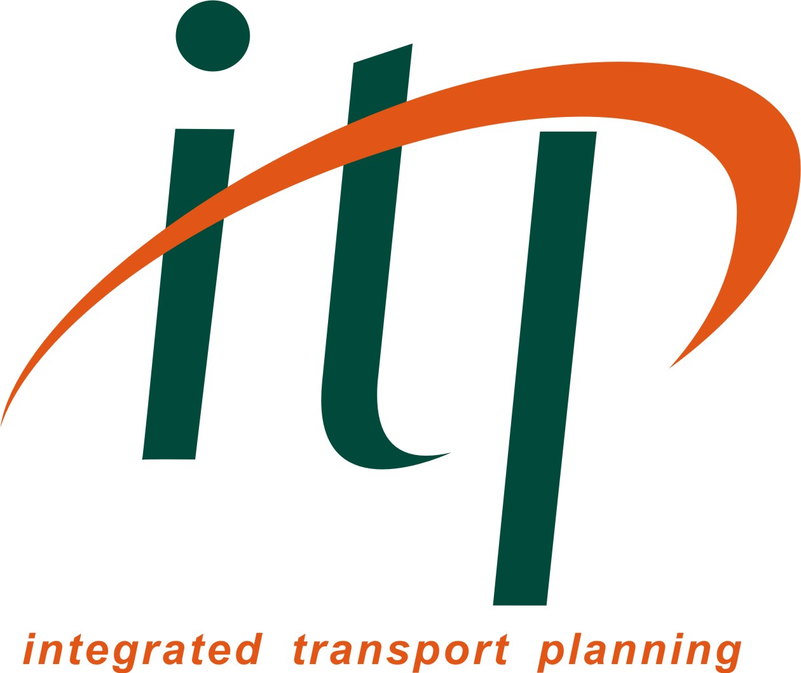
Thursday 7th March 2013
18:00 for prompt start at 18:30

2013 TPS National Pub Quiz!

North West Region Event at:
Seven Oaks, Nicholas Street, Manchester, M1 4HL

To enter, team captains should provide the following information:

Team captain:
Name of TPS member:
Membership No:
Email address:
Phone no.:
Team name:
Organisation(s):
Expected number in team: | (Maximum of 5)

If you would like to be teamed up with other individuals on the night, please provide your name and contact details below:

Name:
Phone:
Email:

We will send you more details of the food available in due course.

As usual, we will collect all entry fees (£2 for TPS members, £3 for non-members) on the evening.

PLEASE COMPLETE THIS FORM AND EMAIL TO chris.smith@aecom.com

