
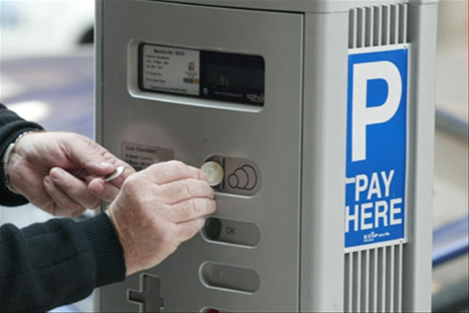

Tuesday 20th September 2011
17:30 for prompt start at 18:00

TPS Parking Debate:

Parking Charges and Levies within Strategic Centres in the West Midlands

Event Location:
Amey, Colmore Plaza,
20 Colmore Circus Queensway,
Birmingham B4 6AT

TPS West Midlands brings you the opportunity to participate in a lively discussion on the changing policies with regard to the implementation of parking charges and levies within strategic centres.

Howard Potter from Scott Potter Associates will lead the debate on parking and find out your views on the impacts current and future changes in parking charges within the West Midlands. Some of the questions and discussion points will be:

- The dilemma of attracting custom (lowering parking charges) during a recession and needing more revenues.
- The future for a more comprehensive parking levy.
- Impacts from the new parking charges proposed for Birmingham and wider West Midlands Region.

Spaces for this event are strictly limited and will be allocated on a first come first served basis.

This event is free for TPS members (with membership card) and £5 for non-members.

Refreshments will be available from 17:30.
This event is open to both TPS members and non-members.
Please confirm your attendance via email at the earliest opportunity.

Register your place by emailing amrit.mudhar@mottmac.com

