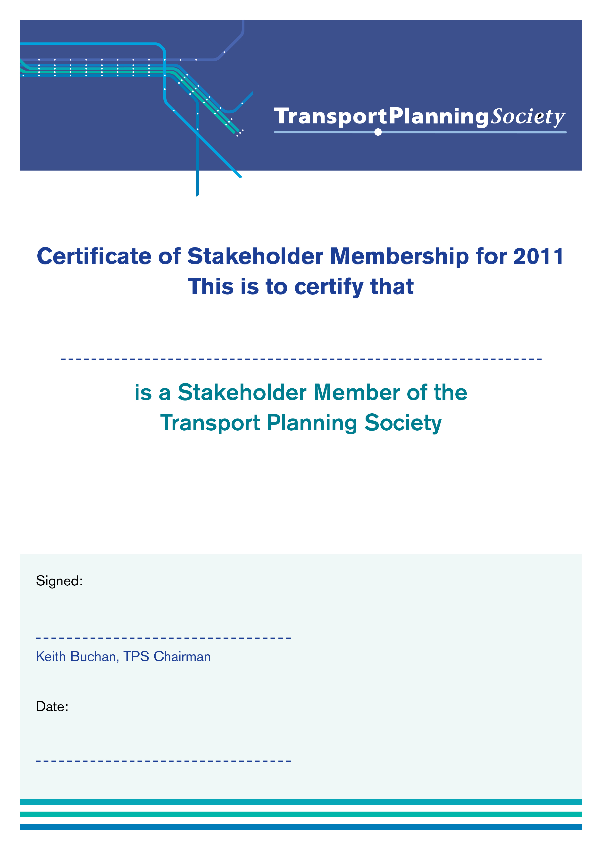

Only Slight Dip in Transport Masters Student Numbers
Defying expectations of a big fall in the number of students studying for a transport Masters, the annual TPS survey of transport Masters students at ten UK universities shows that the total number of students – measured as Full Time Equivalents (FTES) – fell by just 8.5%. This year’s total is 335 students (FTEs), compared with 367 last year.
But that hides the expected bigger decline in the number of UK students, the total of which fell by 26% – down from 175 last year to 133 this year. As expected, the biggest decline -.33% - is in part time UK students, many of which receive financial support from their employers. This continues a decline that started with the onset of the recession and austerity measures. The number of full time UK students has fallen by 12% over the past year.

 | Total 2011/12 |  | Total 2010/11 |  | Change 2011 wrt 2010 | %age change
Category | Total FTEs |  | Total FTEs |  | Total FTEs
UK full time students | 57.0 |  | 65.0 |  | -8.0 | -12.3%
UK part time students starting 2011 | 32.0
UK part time students continuing from previous years | 44.3
UK part time students Total | 76.3 |  | 114.2 |  | -37.9 | -33.2%
Other EU | 64.7 |  | 72.7 |  | -8.0 | -11.0%
Rest of the World | 136.7 |  | 114.0 |  | 22.7 | 19.9%
Total | 334.6 |  | 365.8 |  | -31.2 | -8.5%
Principal Source of Funding for UK students
Funding Source | Full Time | Part Time - FTEs | Full Time | Part Time - FTEs | Full Time | Part Time - FTEs
Public grant (Research Council etc) | 0.0 | 0.0 | 6.0 | 0.0 | -6.0 | 0.0
Rees Jeffreys Bursary | 9.0 | 0.0 | 7.0 | 0.0 | 2.0 | 0.0
Other Full Bursary/Studentship | 5.0 | 0.0 | 3.0 | 0.4 | 2.0 | -0.4
Other Bursary (ie not "full") | 12.0 | 17.9 | 6.0 | 7.0 | 6.0 | 10.9
Full Employer, fees, salary, costs | 4.5 | 43.2 | 1.0 | 85.9 | 3.5 | -42.7
Partial Employer | 3.0 | 5.5 | 0.5 | 8.2 | 2.5 | -2.7
Fully Self Funding | 29.0 | 3.2 | 41.5 | 12.7 | -12.5 | -9.5
Other | 7.0 | 0.0 | 0.0 | 0.0 | 7.0 | 0.0
Total | 69.5 | 69.8 | 65.0 | 114.2 | 4.5 | -44.4

The falls in UK student numbers were offset by a 20% increase in students from outside the EEA, but student numbers from the EEA excluding the UK fell by 11%.
The participating universities in the annual TYPS census are Cardiff, Edinburgh Napier, Imperial College/UCL, Leeds, Loughborough, Newcastle, Salford, Southampton, UWE and Westminster. Although Oxford Brookes was included in previous years, it is not providing a transport Masters course this year.

Martin Richards, the Society’s Skills Director, said
“While the fall in UK numbers is worrying in a medium to longer term context, we must recognise that the impact of the recession and austerity measures on transport planning has been severe, and that some of this year’s Masters graduates have been struggling to find a job in transport. However, it is good to note the increase in foreign students, which will help ensure the viability of the courses.
Looking to the future, the changes in funding for English universities from 2012, when there will be a big increase in undergraduate fees, had been expected to lead to a comparable increase in fees for Masters courses. However, the publication of 2012/13 Masters fees by Imperial College London (£3,500 pa for part-time UK students and £7,000 for full-time) and the University of Leeds (£2,450 pa for part-time UK students and £4,900 for full-time) indicates that the increases are likely to be much less than first expected. Hopefully, at these levels some employers will be able to continue to support staff studying for a transport Masters”

For further information contact

Martin Richards TPP
Director – Skills, Transport Planning Society
www.tps.org.uk
T: 01306 711885
M: 07785 928 719

