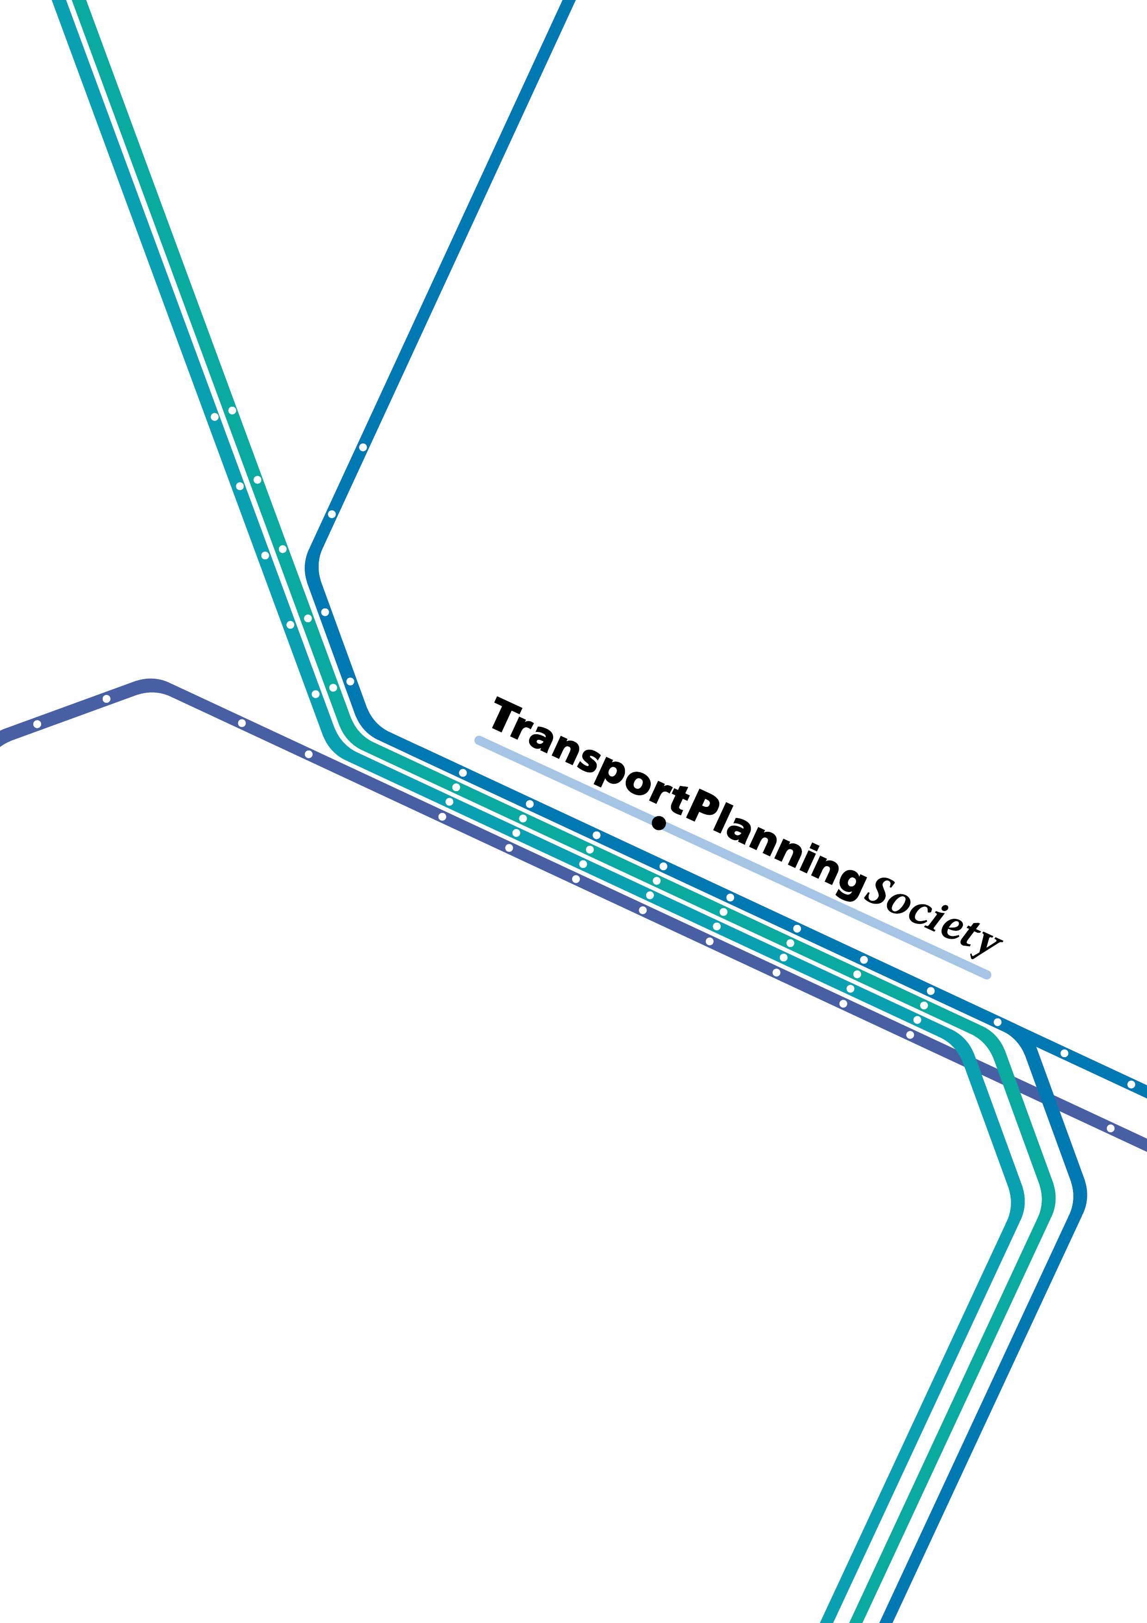

The TPS
Code of Professional Conduct
for Designated Members

version 1 - June 2008

© The Transport Planning Society 2007

This document has been structured to be printed double-sided

This Code of Professional Conduct gives details (in Section 1) of the Rules of Professional Conduct which govern the ethical behaviour of all TPS Designated Members. This is followed, in Section 2, by the Disciplinary Procedure which will be followed in the event of a complaint against a Designated Member of the Transport Planning Society.

Section 1
Rules of Professional Conduct

1 Introduction
This section covers, in plain language, those basic things that Designated Members must do to ensure that they behave in an ethical way. These Rules are based closely on the Statement of Ethical Principles issued by the Royal Academy of Engineering, and has been adapted to allow for non-engineering applications and the particular environment within which Designated Members of the Transport Planning Society (the Society) operate.

In the course of their careers Designated Members may undertake roles which remove them from direct involvement with professional matters. This does not, however, remove from them the obligation, as Designated Members of the Society, to act in accordance with the Rules of Professional Conduct in all aspects of their professional lives.

Accuracy and Rigour
Designated Members of the Society have a duty to ensure that they acquire, and use wisely and faithfully, the knowledge that is relevant to their work in the service of others.
They must:
- always act with care and competence
- perform services only in areas of their current competence.
- keep their knowledge and skills up to date and assist the development of appropriate transport planning knowledge and skills in others.
- not knowingly mislead anyone, or allow others to be misled, about professional and technical matters.
- present and review professional and technical evidence, theory and interpretation honestly, accurately and without bias.
- identify, evaluate and, where possible, quantify risks.

Honesty and Integrity
Designated Members of The Transport Planning Society must adopt the highest standards of professional conduct, openness, fairness and honesty.
They must:
- be alert to the ways in which their work might affect others and duly respect the rights and reputations of other parties.
- avoid deceptive acts, take steps to prevent corrupt practices or professional misconduct, and declare conflicts of interest.
- reject bribery or improper influence.
- act for each employer or client in a reliable and trustworthy manner.
- respect the confidentiality of information gained in the course of their work.

Respect for Life, Law and the Public Good
Designated Members of the Society must give due weight to all relevant law, facts and published guidance, and the wider public interest.
They must:
- ensure that their work is lawful and justified.
- minimise and justify any adverse effect on society or on the natural environment for their own and succeeding generations.
- take due account of the limited availability of natural and human resources.
- hold paramount the health and safety of others.
- avoid maliciously or recklessly injuring or attempting to injure the reputation of another person
- act honourably, responsibly and lawfully and uphold the reputation, standing and dignity of the profession.

Responsible Leadership: Listening and Informing
Designated Members of the Society must aspire to high standards of leadership in the exploitation and management of technology. They hold a privileged and trusted position in society, and are required to demonstrate that they serve wider society and to be sensitive to public concerns.
They must:
- be aware of the issues that the professions associated with transport planning raise for society, and listen to the aspirations and concerns of others.
- actively promote public awareness and understanding of the impact and benefits of achievements in transport planning.

Section 2

Disciplinary Procedure

1 Professional Conduct Panel (‘PCP’)

1.1 Terms of reference
- To investigate
- any allegation relating to the professional conduct of a Designated Member either made by a complainant against a Designated Member or which otherwise comes to the attention of the Transport Planning Society (the Society);
- any criminal conviction or bankruptcy of a Designated member;
- any false representation by a Designated member; that may come to the attention of The Transport Planning Society; and
- any adverse finding by another organisation concerning the conduct of a Designated Member.
- To investigate any misrepresentation of Designated Membership of the Society, and any misuse by a Designated member of the title “Transport Planning Professional’ and/or the post-nominals “TPP”
- To act on the results of the investigation on behalf of the Society.

1.2 Constitution
- Upon receipt of a complaint, a Professional Conduct Panel (PCP) shall be established by the Chair of the Society and shall comprise
- a Past Chair to act as Chair;
- at least two and not more than three Designated Members of the Society
- if required, up to three other persons co-opted by the PCP.
- Membership of the PCP shall be personal and may not be delegated to another.
- The quorum shall be three members (excluding co-opted persons) of the Panel.
- The PCP may appoint a legal adviser, who shall not be a member of the PCP and who shall have no vote.

1.3 Powers
The PCP may
- decide that there is no case to answer; or
- decide that there is a case to answer, but that the conduct in question is not sufficiently serious to warrant referring the matter to a Disciplinary Panel, in which case the PCP may issue a formal warning to the Designated Member in such terms as it deems fit, which may include a requirement to give an undertaking in respect of future conduct; or
- decide that there is a case to answer, and that the conduct in question is sufficiently serious, and refer the matter to a Disciplinary Panel.

1.4 Investigation procedure
- The complainant (if there is one) shall make the complaint in written form.
- In cases of false representation, criminal conviction or bankruptcy, or an adverse finding by another organisation, in the absence of a complainant, the secretariat of the Society shall prepare a report detailing the matter at issue. The PCP shall satisfy itself as to the prima facie accuracy of the allegation.
- The complainant’s submission or the report shall be sent by the Society to the Designated Member who is the subject of the complaint, who shall be required to respond in writing as soon as reasonably practicable after the submission or report has been received and in any event within 42 days of receipt.
- The Designated Member’s response shall be disclosed to the complainant. The complainant may reply but shall not be entitled to raise any new allegations. The complainant’s reply (if any) shall be passed to the Designated Member.
- All written submissions shall be provided to all the members (and, if appointed, the legal adviser) of the PCP.
- If the Designated Member fails to respond to the allegation within 42 days, the PCP may proceed without further reference to the Designated Member.
- Neither the Designated Member nor the complainant shall appear before the PCP in person.
- The PCP shall meet in private.
- The PCP shall confine itself to the consideration of the written evidence.
- Decisions of the PCP shall be based on an assessment of the balance of probabilities, and shall be made by a simple majority. No member of the PCP present shall be allowed to abstain. If there is no majority decision, the Chair shall have a casting vote.
- If the PCP decides that there is a case to answer, the PCP, when considering the appropriate course of action, shall be entitled to take into account any information concerning the previous conduct of the Designated Member.
- If the PCP decides to refer the matter to a Disciplinary Panel, it shall, within 21 days of such decision:
- submit to the Disciplinary Panel all written evidence submitted by the complainant and the Designated Member; and
- give notice to the Designated Member and the complainant (if any) that the complaint has been so referred.
- The PCP shall inform the Designated Member and the complainant of its decision within five working days of the meeting at which the decision was made.
- The PCP may, at its sole discretion, give reasons for its decision to the complainant and the Designated Member.
- The PCP shall not have power to review or set aside any previous decision it has made.

2 Disciplinary Panel

2.1 Terms of reference
To consider and to adjudicate upon any complaint or report relating to the professional conduct of a Designated Member referred to it by the PCP.

2.2 Constitution and administration
- The Disciplinary Panel shall comprise three persons.
- The Chair, who shall be appointed by the Chair of the Society, shall not be personally or professionally acquainted with the Designated Member or the complainant.
- The Chair of the Panel shall appoint the other two Designated Members, who shall not be Designated Members of the PCP and who shall not have any prior knowledge of the parties or the complaint.
- The quorum shall be the full Disciplinary Panel.
- A separate Disciplinary Panel shall be constituted for each complaint or report referred by the PCP.
- At the discretion of the Chair, the Disciplinary Panel may sit with a legal adviser.
- The legal adviser shall not be a member of the Disciplinary Panel and shall have no vote.

2.3 Powers
The Disciplinary Panel may decide that there is no case to answer by the Designated Member or, if the complaint or report is admitted or upheld, it may take any one or more of the following courses of action:
  - Issue a formal warning to the Designated Member in such terms as it deems fit;
  - Reprimand the Designated Member in such terms as it deems fit;
  - Suspend the Designated Member from Designated Membership of the Society for such period as it may determine;
  - Permanently expel the Designated Member from the Society.
In the event of a decision to pursue either suspension or expulsion, the Society will inform the Transport Planning Professional Register, requesting that the Designate Member’s name be removed forthwith, in the case of c for the duration of the suspension.

2.4 Procedure of the Disciplinary Panel
- The written evidence submitted to the PCP (but excluding any other documentation originated by the PCP) shall be provided to the Disciplinary Panel.
- The Disciplinary Panel shall set a date for a hearing by the Disciplinary Panel, giving the complainant (if any) and the Designated Member not less than 40 clear days’ notice.
- The written evidence considered by the PCP shall be provided to the Designated Member at the same time that the notice of the hearing date is given to the Designated Member.
- The Designated Member shall be entitled to appear before the Disciplinary Panel if he or she wishes, and the Disciplinary Panel shall have power to require the Designated Member to attend before it if it so wishes.
- The Designated Member may, at the Designated Member’s own cost, be legally or otherwise represented.
- A Designated Member intending to appear before the Disciplinary Panel hearing, and/or to be represented, shall give not less than 28 clear days notice of that intention.
- The Designated Member may call witnesses, or provide written statements from any witnesses, in support of his or her case.
- The Designated Member shall submit a written statement of their own evidence, and a written statement of the evidence of any other witness on which the Designated Member relies, to the Disciplinary Panel not less than 28 clear days before the hearing.
- The Disciplinary Panel may invite the complainant to attend the hearing or to provide a written statement in support of the complaint.
- If the complainant having been invited to attend the hearing does not attend, the Disciplinary Panel shall be entitled to proceed without further reference to the complainant.
- Any written statement provided to the Disciplinary Panel by or on behalf of either party shall be sent by the Disciplinary Panel to the other party not less than 21 days before the hearing.
- The hearing shall normally be held in London (unless otherwise determined by the Chair) and shall be in private (unless otherwise determined by the Chair).
- The hearing shall be minuted or recorded by electronic or other means as the Disciplinary Panel shall determine.
- The procedure shall ordinarily be as follows:
- the Chair shall open the hearing and invite those present to identify themselves. The Chair shall state that the hearing will be recorded;
- the Chair shall read out a summary of the complaint and ask whether the Designated Member admits all or any part of it;
- if the Designated Member admits all of the complaint, the Chair shall invite the Designated Member or their representative to make a statement to the Disciplinary Panel and the Disciplinary Panel shall then proceed in accordance with paragraph 2.5 below; and
- if the Designated Member does not admit the complaint or admits only part of it, the Disciplinary Panel shall then proceed in accordance with paragraph 2.6 below.

2.5 Procedure if the Designated Member admits all of the complaint
- The Disciplinary Panel shall withdraw to consider its decision and its withdrawal shall conclude the hearing.
- In considering a sanction, the Disciplinary Panel will take into account any previous complaints, and any reports of a criminal conviction, bankruptcy, false representation or adverse finding by another organisation concerning the conduct of the Designated Member that have been upheld, and any sanctions that have previously been imposed and any formal warnings by the PCP.
- The decision of the Disciplinary Panel shall be made by a vote. The courses of action in paragraphs 2.3 a and b shall require a majority decision on the balance of probabilities, but the courses of action in paragraph 2.3 c and d shall require a unanimous decision that the matter is beyond reasonable doubt. No member of the Disciplinary Panel may abstain.

2.6 Procedure if the Designated Member does not admit all of the complaint
- The process shall be formal and rigourous
- If the complainant is present, he or she will be invited to put his or her case to the panel.
- If the Designated Member is present, he or she (or his or her representative) will be invited to make an opening statement to the panel summarising his or her case.
- If the Designated Member relies on evidence contained in witness statements alone, the Designated Member or their representative shall identify the witness and the relevant written statement to the Disciplinary Panel during their opening statement.
- Either the Designated Member or their representative may then put questions to the complainant (if any) relevant to the complaint.
- After the Designated Member or their representative has put questions to the complainant (if any), the Disciplinary Panel may put additional questions to the complainant (if any).
- The Chair shall then ask the Designated Member or their representative if they wish to call any witnesses. If any witnesses are called on behalf of the Designated Member, each shall be questioned in turn, first by the Designated Member or their representative and then by the complainant (if any) and then by the Disciplinary Panel.
- The Designated Member or their representative shall be entitled to ask further questions of the witnesses called by the Designated Member, but such questions shall be strictly limited to any matter arising out of questions put by the complainant or the Disciplinary Panel.
- The members of the Disciplinary Panel shall be entitled to ask any party or witness any question relevant to the complaint at any time during the course of the hearing.
- The Chair shall ask the Designated Member or their representative to make a closing statement to the Disciplinary Panel.
- In the absence of oral evidence from a complainant, the Designated Member or any witness, as the case may be, the Disciplinary Panel shall be entitled to place such weight as it deems appropriate on the documentary evidence including any written statement of evidence.
- If the particular circumstances of the case reasonably require, the Chair shall be entitled to vary the procedure of the Disciplinary Panel, and adjourn the hearing at any time.
- The Disciplinary Panel shall withdraw to consider its decision and its withdrawal shall conclude the hearing.
- In the event of the complaint being upheld, in considering the sanction, the Disciplinary Panel shall take into account any previous complaints, and any previous reports of a criminal conviction, bankruptcy, false representation or adverse finding by another organisation concerning the conduct of the Designated Member that have been upheld, and any sanctions that have previously been imposed and any formal warnings by the PCP.
- The decision of the Disciplinary Panel shall be made by a vote. The courses of action in paragraphs 2.3 a and b shall require a majority decision on the balance of probabilities, but the courses of action in paragraphs 2.3 c and d shall require a unanimous decision that the matter is beyond reasonable doubt. No member of the Disciplinary Panel may abstain.

2.7 Action after the hearing
- The Disciplinary Panel shall send by recorded delivery within five days of the hearing to the Designated Member and the complainant (if any) its decision in writing and, at its sole discretion, may give reasons for the decision.
- The Disciplinary Panel shall not have power to review or set aside any previous decision it has made.

2.8 Publication of the decision
The decision of the Disciplinary Panel shall be reported to the Society’s Executive Committee and shall be published on the Society’s website. In the case of suspension or permanent expulsion, the name of the Designated Member shall be included, but no announcement shall be published until after the period for lodging an appeal has passed or, if an appeal is lodged, until after the completion of the appeal process.

3. Appeals

3.1 Entitlement and arrangements for appeal
- The Designated Member shall be entitled within three calendar months of receipt of the Disciplinary Panel’s decision to lodge an appeal against the decision of the Disciplinary Panel.
- Designated Members may appeal on the following grounds:
  - that the defined process for considering a complaint has not been followed, or has been in some way flawed;
  - that the conclusion of the Disciplinary Panel is perverse; or
  - that new information, not available to the Disciplinary Panel at the initial hearing, would be likely to change the conclusion of meeting.
- Any such appeal shall be by written notice sent by recorded delivery to the Chair of the Society at its registered address, and shall specify the grounds of appeal.
- The Chair of the Society will arrange for an Appeals Panel to be established.

3.2 Appeals Panel: Terms of reference
To consider and to adjudicate upon an appeal against the decision of a Disciplinary Panel relating to the professional conduct of a Designated Member.

3.3 Constitution and administration
- The Appeals Panel shall comprise two persons; the Chair shall be the Chair for the time being of the Society who will sit together with one other member of the Society’s Executive Committee.
- The Chair and the other member of the Society’s Executive Committee shall not have any prior knowledge of the complaint.
- In the event that the Chair has been involved at a previous stage of the procedure a Past Chair shall chair the Appeals Panel
- The quorum shall be the full Appeals Panel.
- At the discretion of the Chair, the Appeals Panel may sit with a legal adviser.
- The adviser shall not be a member of the Appeals Panel and shall have no vote.
- The appeal shall be conducted in accordance with the Procedures of the Disciplinary Panel set out above.
- The Designated Member shall be bound by the decision of the Appeals Panel which shall have heard the appeal.

3.4 Powers
The Appeals Panel may decide that there is no case to answer by the Designated Member or, if the complaint or report is admitted or upheld, it may take any one or more of the following courses of action:
  - confirm that decision of the Disciplinary Panel.
  - rescind the decision of the Disciplinary Panel.
  - substitute the action of the Disciplinary Panel with an alternative sanction.

4. Suspension and Permanent Expulsion

4.1 A Designated Member who is suspended from Designated Membership shall immediately return the Transport Planning Professional certificate to the Secretary of the Society. Such a Designated Member shall not, during the period of suspension, be entitled to exercise any of the rights or privileges of Designated Membership of the Society or to use any title, designatory letters, logo or description implying that they are a registered Transport Planning Professional or a Designated Member of the Society, but shall remain in all other respects subject to the Memorandum and Articles of Association of the Transport Planning Society Ltd and to the code of conduct.

4.2 A Designated Member who is permanently expelled from Designated Membership shall thereupon cease for all purposes to be a Designated Member of the Society, and shall immediately return the Transport Planning Professional certificate to the Secretary of the Society, and shall not be entitled to use any title, designatory letters, logo or description implying that they are a registered Transport Planning Professional or a Designated Member of the Society.

4.3 In the event that a Designated Member is either suspended or expelled from the Society, the Society will inform the Transport Planning Professional Register, requesting that the Designated Member’s name be removed forthwith, in the case of suspension for the duration of the suspension.

5. No Entitlement to Resign
Once a Designated Member has been notified that an allegation has been made, or that the Designated Member’s criminal conviction, bankruptcy or disciplinary finding against them by another organisation is to be investigated by the PCP, the Designated Member shall not be entitled to resign, and shall not be removed from Designated Membership of the Society until all proceedings under these Regulations have been concluded, and any such proceedings may be continued notwithstanding the Designated Member’s attempted or purported resignation.

