What is the future for Roads and Streets in Urban Areas?

6pm, Thursday 5th June 2014

Ahm-Martin Room, Arup, 13 Fitzroy Street, London, W1T 4BQ

Please come along to hear our speakers and join the discussion on the future of roads and streets in urban areas.

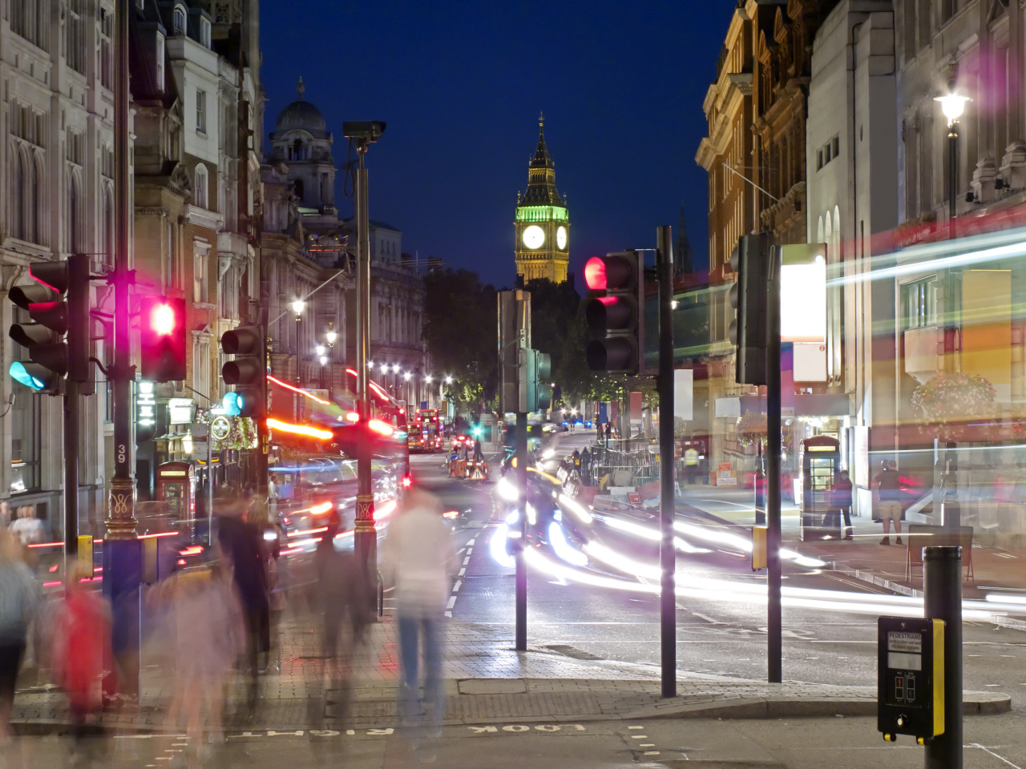
Mike Keegan Policy Manager, Planning, Transport for London
- The Mayor’s Roads Task Force set out its vision for London’s roads and streets in July last year. Find out how TfL is taking forward this vision to give the capital roads fit for the 21st century.

John Dales Director, Urban Movement Ltd
- Roads, Streets and Liveable Cities: ensuring the tail doesn't wag the dog

Refreshments will be available.

Booking your place - New online booking procedure - To book your place at this event please visit http://www.ice.org.uk/Event?ID=2499. If you do not currently have access to a MyICE account please register and this will allow you to book yourself on all future TPS events. Please note if you are a Corporate/Stakeholder member of TPS you will need to register as a non-member rather than a member as the membership number relates to ICE not TPS.

If you require advice or are unable to book yourself on this event please contact Pauline Arundel on pauline.arundel@ice.org.uk or 020 7665 2236.

Please note that entrance to the event is free for TPS members with their membership card. A £10 fee applies to non-members. The fee is payable on the evening.

Certificates of attendance are available to TPS members. Please ensure you sign the register on the night and indicate your request for a certificate and these will be issued to you electronically after the event.

