 |  | 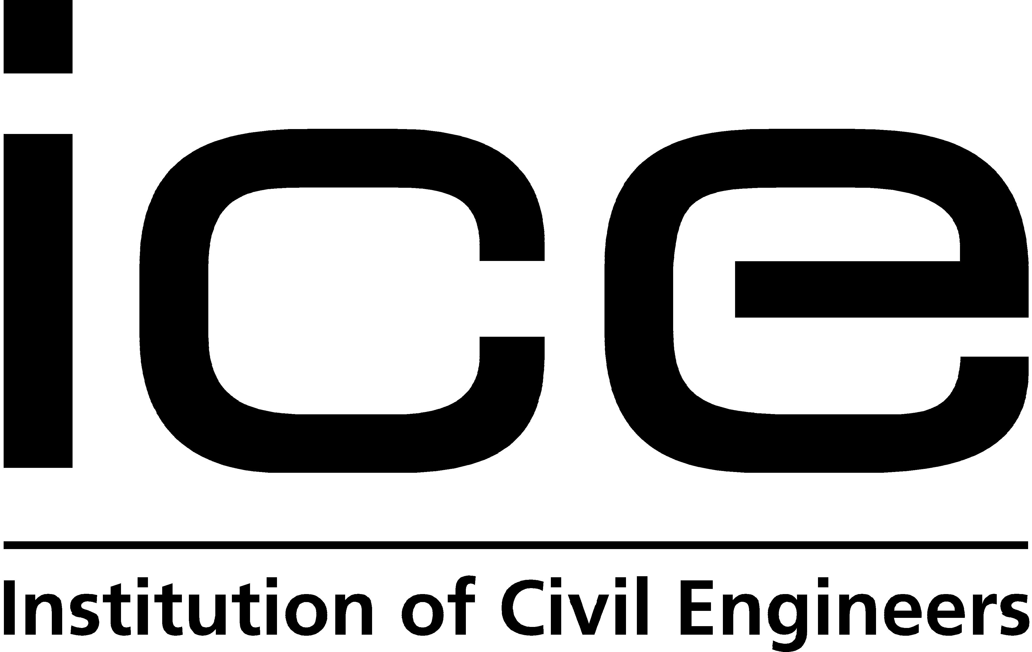

The Institution of Civil Engineers and Institution of Mechanical Engineers invite you to attend:

The London Transport Debate
Reducing carbon, increasing capacity
How soon zero carbon transport for London?

Tuesday 25th November 2008

How can we move towards a low carbon future for London’s transport without compromising the city’s economy? London’s leading professional engineers will unite with high profile figures from London’s government, business and transport planning communities to discuss what a zero carbon future for London’s transport will look like and how we will get there.

With
Ms Jenny Jones AM (Green), London Assembly Member
Dr Michele Dix, Managing Director of Planning, Transport for London
Dr Robin Hickman, Transport Planning Society
Professor Roderick Smith, Institution of Mechanical Engineers
Professor Richard Folkson, Institution of Mechanical Engineers

Chaired by Mr Paul McCormick, ICE Transport Board chairman

At
The Institution of Mechanical Engineers
One Birdcage Walk
Westminster
SW1H 9JJ

6.00pm for 6.30pm start
A reception with drinks will follow the debate

Places are limited and pre-registration is required.
To secure your place please contact caroline.hunt@ice.org.uk

