
Are our Appraisal Methods of Transport Schemes & Initiatives fit for Purpose?

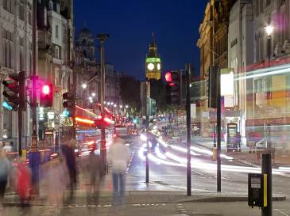
6pm, Thursday 18th September 2014

Godfrey Mitchell Theatre, Institution of Civil Engineers, One Great George Street, London, SW1P 3AA

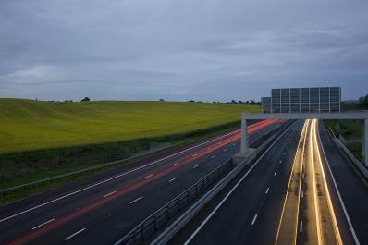
There is an ongoing debate within the profession as to whether our methods for the appraisal of transport schemes and initiatives are providing the information that decision-makers really need. Concerns have been raised, for example, whether current appraisal reflect all the relevant impacts of schemes and policies, whether these are valued appropriately and whether the focus on monetised impacts of individual schemes leads to a coherent long term transport policy. Finally, there are doubts whether our existing modelling toolkit is up to the task. A thorny subject but at the heart of how we professionally support transport related decision-making. Join the debate. Our speakers are:

David Metz is visiting professor at the Centre for Transport Studies, University College London, formerly Chief Scientist at the Department for Transport, and author of the recently published ebook 'Peak Car: the Future of Travel'.

Tom Worsley is a Visiting Fellow at the Institute for Transport Studies at the University of Leeds, which he joined after spending many years as a senior economist in the Department for Transport. He has written and researched on the interaction between transport policy and economic appraisal and on the role of evidence in supporting the decisions facing government ministers and other politicians.

Tom van Vuren is, as he says himself, “passionate about transport modelling”. He has worked in academia and in practice, building and using models to support policy and project appraisal. This experience has taught him that good models are both science and art: transparent, robust and defensible in their development but in application cognisant of their simplifications, sparse data inputs and future assumptions made. Tom will explore whether and how models may be used better as input to the appraisal process. He is a Divisional Director at Mott MacDonald and Visiting Professor at the University of Leeds.

For those of you unable to travel to London, you can follow the debate online:
https://ice-org.webex.com/ice-org/onstage/g.php?t=a&d=703151732

To book your place at this event please visit http://www.ice.org.uk/Event?ID=2727. If you do not currently have access to a MyICE account please register and this will allow you to book yourself on all future TPS events. Please note if you are a Corporate/Stakeholder member of TPS you will need to register as a non-member rather than a member as the membership number relates to ICE not TPS. If you require advice or are unable to book yourself on this event please contact Pauline Arundel on pauline.arundel@ice.org.uk or 020 7665 2236. Please note that entrance to the event is free for TPS members with their membership card. A £10 fee applies to non-members. The fee is payable on the evening.
Certificates of attendance are available to TPS members. Please ensure you sign the register on the night and indicate your request for a certificate and these will be issued to you electronically after the event.

