AGENDA

Arrival of Delegates  Tea / Coffee / Refreshments  Introduction by Chair  – Alan Wenban-Smith  David Strahan  – The Last Oil Shock Presentation  Open Debate  Chairs Closing Remarks  Raffle Draw | 18:00  18:00 – 18:30  18:30 – 18:35  18:35 – 19:30  19:30 – 20:15  20:15 – 20:20  20:20 – 20:30

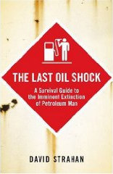
Sponsored by:

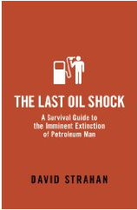


FUTURE TPS EVENTS

28th August 2009 Beer Bus

15th October 2009 Best Practice Projects Seminar

4th December 2009 Transport Planning Society Christmas Social

January 2010 TBC

4th March 2010 Annual Pub TPS Quiz

--------------------------------------------
FEEDBACK

Please could you spare a moment to provide some feedback on your thoughts about this evening’s presentation/debate and about future events in the West Midlands you may be interested in attending. Thank you.

The Last Oil Shock:

----------------------------------------------------------------------------------------------------------------

----------------------------------------------------------------------------------------------------------------

----------------------------------------------------------------------------------------------------------------

Future TPS events:

----------------------------------------------------------------------------------------------------------------

----------------------------------------------------------------------------------------------------------------

----------------------------------------------------------------------------------------------------------------
Alternatively, please send any feedback you may have to Amrit Mudhar or Paresh Shingadia (West Midlands TPS Representatives)

amrit.mudhar@mottmac.com paresh.shingadia@mottmac.com

