Here at The Brewery Tap we use only the freshest ingredients. All of our products are locally sourced and our meals hand prepared, fresh on site. You’ll even find our beer in a few of the menu choices too, like our Steak and Midnight Bell Ale Pie, and our very own Leodis Battered Haddock – mouth wateringly good!

Nibbles
Yorkshire Bread & Balsamic Vinegar (v) £2.50
Yorkshire Bread & Olives (v) £2.50
Hummus & Warm Yorkshire Breads (v) £3.50
Selection of Yorkshire Cheeses & Bread (v) £4.50
Soup of the Day (v) £4.00

Sides
Bowl of Seasonal Vegetables (v) £2.75
Side Salad (v) £2.75
Hand Cut Chunky Chips (v) £2.75
Leek, Cheddar & Herb Bites (v) £3. 50

BREWERY TAP SANDWICHES
The best around, all served with Dressed Leaves, Hand Cut Chips,
On your choice of White or Granary Roll.
House Recipe Veggie Sausage & Midnight £5.95
Bell Ale Chutney (v)
Swaledale Sausage & Midnight Bell Ale £5.95
Chutney
Leodis Battered Haddock Goujons with £5.95
Chunky Tartar Sauce
Rump Steak, Mushroom & Yorkshire £6.50
Blue cheese

Brewery Tap Paninis
Served with Dressed Leaves & Hand Cut Chips.
Brie & Bacon Panini £5.25
Brie & Balsamic Onion Panini (v) £5.25
Piri Piri Chicken Panini £5.25
Slow Roast Tomato & Mature Cheddar Panini (v) £5.25

MAIN DISHES
21 Day Aged 8oz Rump Steak, served with £10.95
Hand Cut Chips, Grilled Tomato & Peppercorn
Sauce

Mushroom & Slow Roasted Tomato Risotto (v) £7.50
Perfect liquid partner; a glass of Merlot.

Leek, Cheddar and Herb Sausages, Buttered £8.95
Mash, with Caramelised Red Onion Gravy (v)
Perfect liquid partner; a pint of our Leeds Best Bitter.

Swaledale Sausage, Buttered Mash with £8.95
Caramelised Red Onion Gravy.
Perfect liquid partner; a pint of our Leeds Best Bitter.

Pan Fried Chicken Breast on a Bacon & £8.95
Yorkshire Blue Cheese Risotto
Perfect liquid partner; a glass of Sauvignon Blanc.

Leodis Battered Haddock with Hand Cut £9.50
Chips & Minted Pea Puree
Perfect liquid partner; our very own site brewed Leodis.

Steak & Midnight Bell Ale Pie, with Buttered £9.50
Mash, Seasonal Vegetables & Gravy
Perfect liquid partner; a pint of our Midnight Bell.

Chicken & Bacon Salad with Herbed £8.50
Croutons

Roast Pepper & Parmesan Salad with
Herbed Croutons (v) £7.95
Perfect liquid partner; a glass of Pinot Grigio.
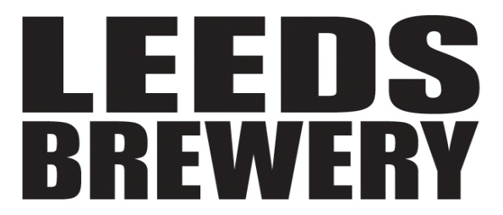

BREWERY TAP BURGERS
All our Burgers come with a healthy portion of our Hand Cut Chips,
Dressed Leaves & Homemade Burger Relish.
Beef burger, topped with Mature Cheddar £8.95
Beef burger, topped with Mature Cheddar £8.95
and Bacon
Beef burger, topped with Yorkshire Blue Cheese £9.50
BBQ Chicken Burger £8.95
Piri Piri Chicken Burger £8.95
Brewery Tap Bean Burger, topped with £8.50
Slow Roasted Tomatoes (v)

Sweet Stuff
Yorkshire Cheeseboard £5.50
Sticky Toffee Pudding & Ice Cream £3.95
Delicious Dark Chocolate Mousse £3.95
Yorvale Ice Cream: £1.00/scoop
Rocky Road
Vanilla Bean

Food Served:
12-9pm Monday – Saturday
12-6pm Sunday
Because we believe in locally sourced food, with only the freshest ingredients, our menu will continue to have new dishes each day. If there is meal you love, let us know, and we’ll do all we can to keep it here for you.
From the team at The Brewery Tap

