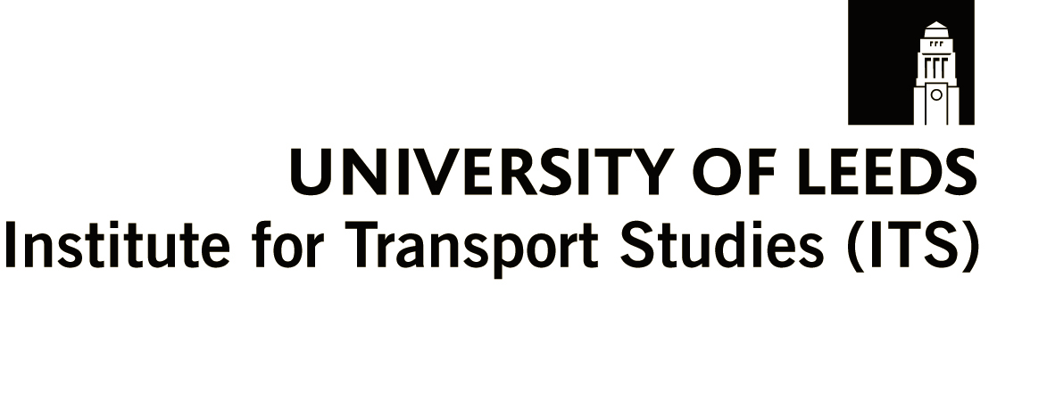
Tuesday 7th July 2009

5.30pm for 6.00pm start.

‘Peak Oil - what is it, and what it may mean for transport planning’

David Strahan, Oil Depletion Analysis Centre

at: University of Leeds Business School, Yorkshire Bank Lecture Theatre

The fundamentals of oil production mean that in each oilfield production reaches a peak and then goes into decline. “Peak Oil” is the prospect of world oil production following the same pattern, with spectacular impacts on its price.

With 95% of transport dependent on oil for fuel, and the price of most other forms of energy closely linked to that of oil, this would represent a major challenge to our way of life and of doing business. A debate over the likely date of peak oil has raged between independent geologists and the oil industry for several years, but a consensus is beginning to emerge that the critical date is closer than many of us realise.

On the plus side, many of the measures needed are the same as those needed to respond to climate change. Can we use this to forge a new alliance between business and environmental interests? What are the implications for our plans for the future?

The Yorkshire and Humber branch of the Transport Planning Society and Institute for Transport Studies, University of Leeds have joined forces to bring a leading expert to Leeds to explain the issues. David Strahan FRSA, author of The Last Oil Shock, is an award winning investigative journalist and documentary maker specialising in presenting complex business and science stores in an accessible way. He worked for 10 years on the BBC’s Money Programme and Horizon. For more information please see www.davidstrahan.com.

This event is free to TPS members and £2 for non-members. Please bring your membership cards with you and confirm your attendance via email as we expect demand to be high. Please register by emailing emma.roberts@arup.com indicating your membership status.

Refreshments will be provided from 5.30pm.

